Muhammad Faheem Irfan 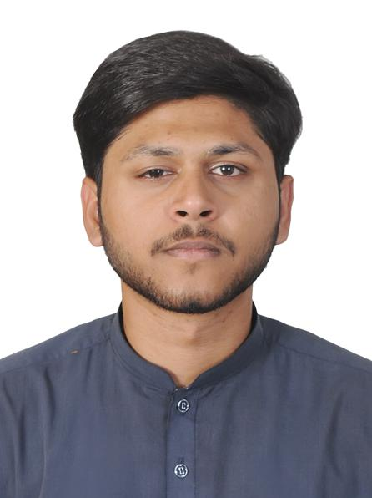

|  |  |  |  |  |  |  |  |  |  |  |  |  |  |  |  |  |  |  |  |  |  |  |  |  |  |  |  |  |  |
| --- | --- | --- | --- | --- | --- | --- | --- | --- | --- | --- | --- | --- | --- | --- | --- | --- | --- | --- | --- | --- | --- | --- | --- | --- | --- | --- | --- | --- | --- |
| |  |  | | --- | --- | |  | **Contact** |   Address:-  Dubai- UAE  Phone:-  **+971 555 233951**  +923244474770 **(Only WhatsApp)**  E-mail:-  [faheemirfan36@gmail.com](mailto:faheemirfan36@gmail.com)  **Passport No.:- JN 1984051**  **Issue Date 13-6-2019**  **Exp. Date 11-06-2024**  **Languages Known:-**  **English- Punjabi- Urdu**   |  |  | | --- | --- | |  | **Skills:-** |  |  |  | | --- | --- | | MS Excel | Very Good |  |  |  | | --- | --- | | MS Word | Very Good |  |  |  | | --- | --- | | Bookkeeping | Very Good |  |  |  | | --- | --- | | Monthly / Quarterly / Year End Reports | Very Good |  |  |  | | --- | --- | | Payroll Process | Very Good |   **Duty & Responsibly:-**   * Good Public Ration Skills & Well-like by Superiors. * A Team Worker & Can Handle work pressure with ease. * Customer Service Oriented. * Dependable & Hardworking. * Excellent Physical Condition. * Communication skills.   **Declaration:-**  I hereby declare that the above statement is true and best of my knowledge and belief. |  | |  |  | | --- | --- | |  | **Work History** |  |  |  |  | | --- | --- | --- | | **9-May,2022**  **to**  **31-Oct,2023** |  | Accountant  **Punjab Colleges, Lahore**   * Maintained up-to-date knowledge on professional accounting standards to manage financial recordkeeping. * Preparing Payroll * Monitored status of accounts receivable and payable to facilitate prompt processing. * Maintained detailed financial records of accounts receivable and payable status and bank reconciliations. * Assisted with monthly and quarterly income statements, balance sheets and cash flow reports to inform decision-makers. * Processed payroll by validating work hours and attendance of employees. * Maintained accurate and complete documentation to facilitate accounting and filing functions. * Cooperated with senior leaders to create operating budgets and initiate financial planning. * Prepared working papers, reports and supporting documentation for audit findings. * Worked with “ **Trade Tracker Marketing Consultant”** as **“ Quality Control Executive “**   1-year in Pakistan.   * Worked with “National **Progressive Distribution (NPD) “as** a **“Sale Marketing Agent”** 1-Year in Pakistan. |  |  |  | | --- | --- | |  | **Education:-** |  |  |  |  | | --- | --- | --- | |  |  | B.Com  University of Punjab  I.Com  **BISE Lahore**  **Metric**  **BISE Lahore** |  |  |  |  | | --- | --- | --- | |  |  |  | |
|  |  |  |