

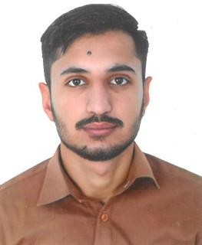

MUHAMMAD FAIZAN NAEEM

**ABU DHABI, UAE**

**Mobile: No. +971-586346742**

**Email:** [**faizansattif4@gmail.com**](mailto:faizansattif4@gmail.com)

***Applied For: Heavy Vehicle Driver***

***Career Objective***

*I wish to attain suitable position in an esteemed organization and wish to use all my constructive abilities and desirous to make my career by enhancing my quality of work as demand to achieve the desired result. I sincerely believe in maintaining a peaceful, friendly and respectable atmosphere at my place.*

# WORK EXPERIENCE

* Presently working as a “Heavy **Vehicle Driver”** with **ABU HUSSAIN CONTRACTING COMPANY LLC** in Abu Dhabi, UAE from 22-04-2022 **to till date.**

***Education Qualification***

* **Matric**

# PERSONAL

Name : MUHAMMAD FAIZAN NAEEM

Date of Birth : 11-12-1999

Gender : Male

Religion : Muslim

Marital Status : Single

Nationality : Pakistani

Language Known : Hindi, Urdu & English Visa Status : Employment Visa

# LICENSE DETAILS

License No. : 1229287

Date of Issue : 16-Oct-2024 Date of expiry : 15-Oct-2026 Issue Place : Abu Dhabi, UAE

Category : Heavy Bus

# PASSPORT DETAILS

Passport No. : DM9955013

Date of Issue : 18-Oct-2024 Date of expiry : 18-Oct-2034 Issue Place : Pakistan

# DECLARATION

I hereby certify that the above information is true and correct according to the best of my knowledge & My Experience. If selected I assure that I would perform to the best of my abilities, early awaiting a Positive response.