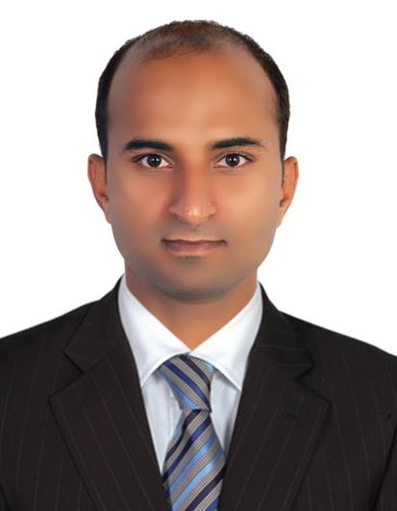

**FARHAN ABBAS**

**FOR ANY JOB**

**PROFILE**

**EXPERIENCE**

**National Tdrs. (Honda Showroom), Pak**

**Sales cum Customer Service Executive**

**Jan 2019 To Oct 2021**

An enthusiastic self-motivated individual with excellent inter personal skills the ability to take responsibility & work as a team. Quality & customer focused with the drive to achieve results. To seek a challenging & responsible assignment in a reputable organization, where I apply my current skills & knowledge

**NADRA (Govt. of Pakistan), Pak**

**Sales cum DEO**

**Dec 2012 To Mar 2013**

**CONTACT**

**DEVCON (NGO), Pak**

**Sales cum DE**

**Feb 2011 To Mar 2011**

+971 55 734 2149

067-phone.png

**QUALIFICATION**

391-mail4.png

**University of Education, Pak**

**Bachelor in Education**

**2011**

alijugno5@gmail.com

001-home.png

DUBAI, UAE

**University of BZ, Pak**

**Bachelor in Arts**

**2007**

016-camera.png032-book.png018-music.png006-pencil.png

**REFERENCES**

**HOBBIES**

**KEY SKILLS**

**PASSPORT & VISA INFO.**

**PERSONAL INFO.**

**Available Upon Request**

* Administration, Documentation & Customer centric
* Serves customers by selling products and meeting customer needs
* Entering customer and account data from source documents within time limits
* Telephone skills & Excellent attention to detail
* Prepares, Compiles sorts documents for data entry
* Maintains a filing system and protects confidential customer information

Photography

Reading

Music

Writing

**Name : Farhan Abbas**

**Gender : Male**

**Religion : Muslim**

**Marital status : Married**

**Language Known : English, Urdu, Hindi**

**Arabic (Learning)**

**Nationality : Pakistani**

**Passport No. : BK1010173**

**Date of Issue : 09-Mar-2016**

**Date of Expiry : 07-Mar-2026**

**Visa Status : Freelance**