FARZEEN HUSSAIN

Administrator

E +923115119265  rajpootfaze7@gmail.com  Erbil s age 25

# EXPERIENCE

Administrator 10/2022 Present

Space Wood Erbil, iraq

* Store keeper
* Preparing, organizing and storing information in paper and digital form
* Dealing with queries on the phone and by email
* Greeting visitors at reception
* Managing diaries, scheduling meetings and booking rooms

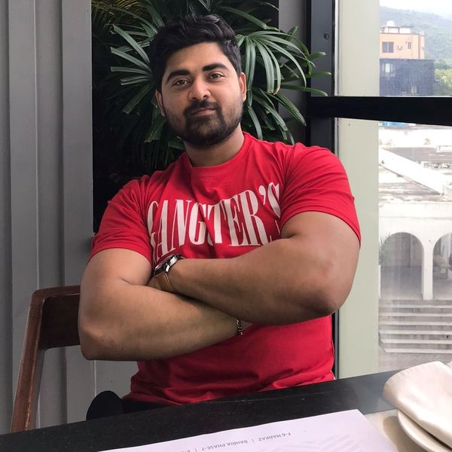

SUMMARY

Administration accounts assistant

Secure a responsible career

opportunity to fully utilize my

training and skills, while making a

significant contribution to the

success of the company 4 YEARS

OF EXPERINCE IN SALES

EXECUTIVE ALONG WITH 2.5

YEARS OF EXPERINCE IN

ADMINISTRATION INCLUDING

DEVELOPING AND SUPPORT

FOR FAST GROWING STARTUPS

TRAINING / COURSES

Fine arts and social science

Fine arts and social science

LANGUAGES

English

Proficient

Punjabi

Native

URDU

Native

ARBIC

Proficient

PASSIONS

Gym

Playing cricket

WORK







Administrator 03/2022 09/2022

United Engineering Ltd Erbil, Iraq

* Administration
* TIME SHEET
* MANAGE MEETINGS

Sales Executive 09/2019 02/2022

Candyland Rawalpindi, Pakistan

## Promote products and services to clients and negotiate contracts

* Aim of maximize profits
* Supervision

# EDUCATION

|  |  |
| --- | --- |
| Matriculation Science | 03/2013 05/2015 |
| Bise | Rawalpindi, pakistan |
| Collage | 06/2017 07/2019 |
| Fine arts and social science | Rawalpindi, pakistan |
| Graduation BBA | 09/2019 01/2022 |
| Preston University | Islamabad, pakistan |
| * Major human resource * Preston University * business administration |  |