**SAMPSON DOKU**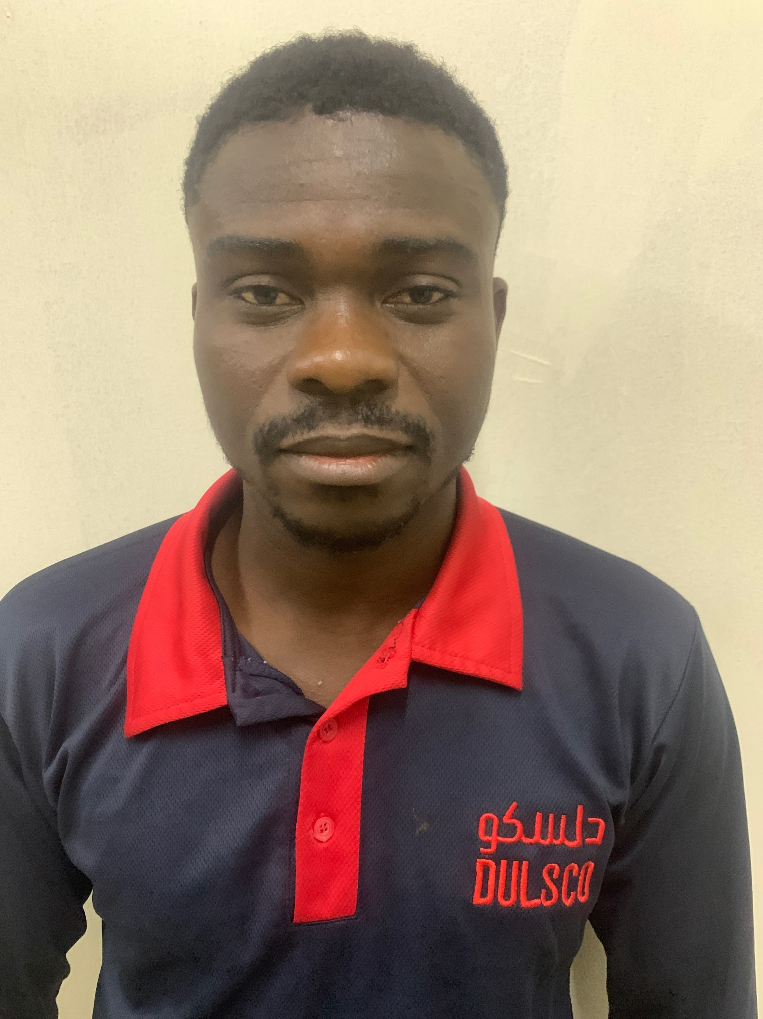

Cellphone No.: +971557982540

Passport Number: G3785544

Expiry Date: 08/09/2032

Emirates ID No.: 784-1993-546623-4

Expiry Date: 13/06/2025

Email Add: sampsondoku0@gmail.com

**Availability**: One (1) Month Notice Period.

**PERSONAL DATA**

Age: 31

Date of Birth: November 11, 1993

Gender: Male

Civil Status: Single

Height: 176 cm

Weight: 75 kg

Nationality: Ghanaian

Religion: Christian (Methodist)

**WORKING EXPERIENCE**

**OBJECTIVES**

Very vibrant young man with good interpersonal relationship who can work under pressure, with or without supervision, highly ambitious personnel with background in IT and Painting, very good with computers expert in Photoshop, Installations of Software and servicing of computers and abreast in Microsoft Office.

1. Position: **Civil Technician (Technical Assistant)**

Duration: September 2021 - PRESENT

Company: **SERCO LIMITED** (Dubai International Airports - DXB)

Company Industry: Facility Management / Maintenance

Location: Dubai, United Arab Emirates

Department: FM Civil Painter

**Job Description**

* Use computer aided design software under the charge of engineers
* Preparing painting surfaces by washing walls, repairing holes, or removing old paint
* Mixing, matching, and applying paints and other finishes to various surfaces
* Providing decorative and faux finishes as the project requires
* Handling planning and prep work in an efficient manner
* Preparing the surrounding area by covering with cloth or plastic to prevent messes
* Moving furniture and equipment as necessary to reach the entire surface of the project
* Calculating the number of materials and time required for said project
* Ensuring work is carried out according to deadlines
* Reducing a project’s impact on the environment
* Working on-site and in an office

1. Position: **Civil Technician (Senior Painter)**

Duration: January 2018 – July 2021

Company: **IMDAAD LLC** (Al Wasl Properties – Karama)

Company Industry: Facility Management / Maintenance

Country: Dubai, United Arab Emirates

Department: FM Civil -Painter

**Job Description**

* Removing fixtures such as doorknobs and light switch covers
* Taping off areas as needed
* Choosing and purchasing paint, brushes, and other supplies from vendors
* Quoting and negotiating job prices
* Cleaning up supplies and replacing fixtures when project is complete
* Communicating with clients to ensure they're getting the look they're hoping for
* Obeying workplace safety rules.
* Prepare reports and document project activities and data
* Set up and help maintain project files and records

**EDUCATIONAL BACKGROUND**

1.Education Level: **The Essential of HEALTH & SAFETY (General)**

School: Highfield International

Location: Dubai, United Arab Emirates

Date: 2021 - 2021

2.Education Level: **Vocational Trade**

School: National Vocational Training Institute (NVTI)

Location: Accra, Ghana

Date: 2015 – 2017

3.Education Level: **Certificate in Graphic Design**

School: NIIT Ghana

Location: Accra, Ghana

Date: 2015 – 2015

4.Education Level: **Senior High School**

School: St. Paul’s Senior High School

Location: Eastern Region, Ghana

Date: 2011 – 2014

Date: 2011- 2014

**QUALIFICATION (CERTIFICATES)**

1. Highfield Level 1 International, The Essential of Health and Safety (General)

2. Vocational Trade Certificate

3. West African Senior School Certificate Examination (WASSCE)

4. Certificate in Graphic Designing (Graphic Design)

**LANGUAGE SPOKEN**

1. English (Native Language)

**Fluent Level**

I am fully verse in this language, speaking, reading and writing it as well as a native speaker.

I can keep up with a fast-paced dialogue between two native speakers of this language.

**PERSONAL SKILLS**

* Ability to communicate clearly
* Computer Skills (**Maximo / MS Office / Data Entry**)
* Critical thinking
* Decision-making
* Understanding of engineering science and technology
* Knowledge of building and construction
* Strong Math
* Problem-solving
* Attention to detail
* Observational

**HOBBY**

* Surfing the Internet
* Cooking
* Sports Games (Football)
* Gaming (Online)
* Music
* Travelling

**REFERENCES**

**Arun Kunnumal**  Line Manager

SERCO LIMITED (Dubai Branch)

Tel.No.: +971 56 412 7287

Arun.kunnumal@serco.ae

**Rajesh Dama**  Area Supervisor

Imdaad LLC

Tel.No.: +971563593014

rajesh.dama@imdaad.ae