**RESUME**

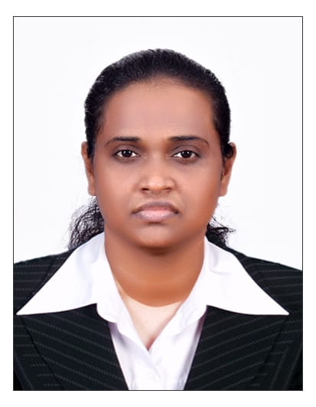**GLYCY VINCENT**

Babahassen Building

Al Qusais 1

Dubai

0543285074

Mebink3@gmail.com

# OBJECTIVE

Awaiting for a company that offers a challenging, stimulating, learning environment to work hard for the development of company as well as self-career growth.

# PREVIOUS EXPERIENCES

* ***Customer Care Executive*** (1.8 years, 2015 Apr to 2016 Dec).

**Company Name: Vertex Customer Care Solutions Pvt Ltd.**

Handled queries regarding tariff, data and sending complaints and requests to technical team, escalate calls to higher level.

* ***Consultant*** (6 months, 2017 Sep to 2018 Mar).

**Company Name: Sutherland.**

Resolved email queries about products replacement, refund, item issues.

* ***Customer Service Assistant*** (1.10 months, 2019 Apr to 2021 Feb).

**Company Name: Essilor Sankar and Co Optics.**

Processed Lense orders, follow ups and coordination with branches.

# ACADEMIC PROFILE

* B. Tech ECE (2014) - K.B.R Engineering College, Telangana - 77.00%
* +2 Bioscience (2009) - G.H.S.S Puthenthodu - 82.00%
* S.S.L.C (2007) - O.L.C.G.H.S.S Thoppumpady – 75%

**CERTIFICATIONS**

* MS Office (Word, Excel, Power point)
* Certifications in Asp.Net and subject knowledge in C, C# and Java
* Certifications in Tally, Gst, Vat, Quick Books and Peachtree

# SKILLS

* Excellent Team worker
* Dynamic and Result Oriented
* Fast learner
* Excellent Technical Knowledge

# ACADEMIC PROJECTS

**1. Project Title**: Driverless Metro train Shuttle between stations

**Description:** This project is designed to demonstrate the technology used in metro train movement used in most developing countries. AT89S52 does the function of driver in the train. Sensors are used by station and train to stop trains in station. There is a counting section to count the people entering the train.

**2. Project Title**: Development of website contain all hotel details.

**Description:** This project is designed for allowing customers to book hotels and food online. By using programming language Asp.net, the website was created. This project is very helpful for customers who travels all day and normal customers too.

|  |  |  |
| --- | --- | --- |
| **PERSONAL DETAILS** |  |  |
| Marital Status | : | Single |
| Nationality | : | Indian |
| Religion | : | Christian |
| Languages Known : Malayalam, English, Tamil, Telugu  Hobbies : Gardening   |  | | --- | | **PASSPORT DETAILS**  Passport No : M8326700  Date of Expiry : 23/04/2025 | | | |