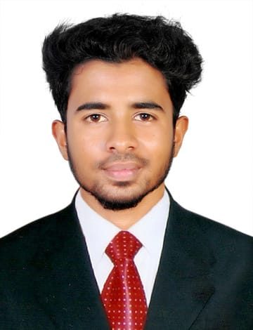
Gokul Gangadharan
Abu Dhabi, United Arab Emirates
gokulgangadharan8131@gmail.com
+971588872997

OBJECTIVE

To be associated with the organization provides me an opportunity to show my skills and improve my knowledge with the latest trends and to be part of a team that works dynamically towards the growth of the organization.

WORK EXPERIENCE
Position: Sales Executive
Company Name: Sharks Friends Sports Hub
Duration: September 2022 – December 2024
Job description and responsibilities:
- Provide personalized assistance to customers, helping them find products suited to their needs and preferences.
- Assist in maintaining stock levels, ensuring the shop is well-stocked with popular and seasonal products.
- Process customer purchases, handle cash and credit card transactions, and issue receipts.
- Track and report daily sales performance and customer feedback to management.
- Assist in arranging product displays and ensuring that the store's visual merchandising aligns with company standards.
- Build and maintain strong customer relationships to encourage repeat business.
- Work closely with other sales staff to achieve store goals and foster a collaborative work environment.
- Maintain knowledge of current stock, promotions, and upcoming trends to inform customers.

Position: Sales Executive
Company Name: Surya Silks Kanhangad
Duration: March 2021 – June 2022
- Present, promote and sell products/services using solid arguments to exist and prospective customers
- Establish, develop and maintain positive business and customer relationships
- Coordinate sales effort with team members and other departments
- Updated management daily; records of sales and orders- tracked progress of existing orders by contacting or liaising with suppliers

Position: Sales Executive
Company Name: Zain Bajaj Kanhangad
Duration: July 2018 – September 2019
- Meeting with clients virtually or during sales visits
- Answering questions about new and vintage bikes
- Meeting monthly sales expectations
- Coordinating test drives for prospective shoppers
- Providing guidance on what motorcycles will best fit the customers profile

SKILLS
- Administrative Skills
- Digital Marketing
- Record Keeping
- Internet Skills
- MS Office
- PDIFAS
- DIFA

EDUCATION

Bachelor of Business Administration
Kannur University, Kerala, India

PERSONAL DETAILS
Date of Birth: 17/08/1995
Nationality: Indian

