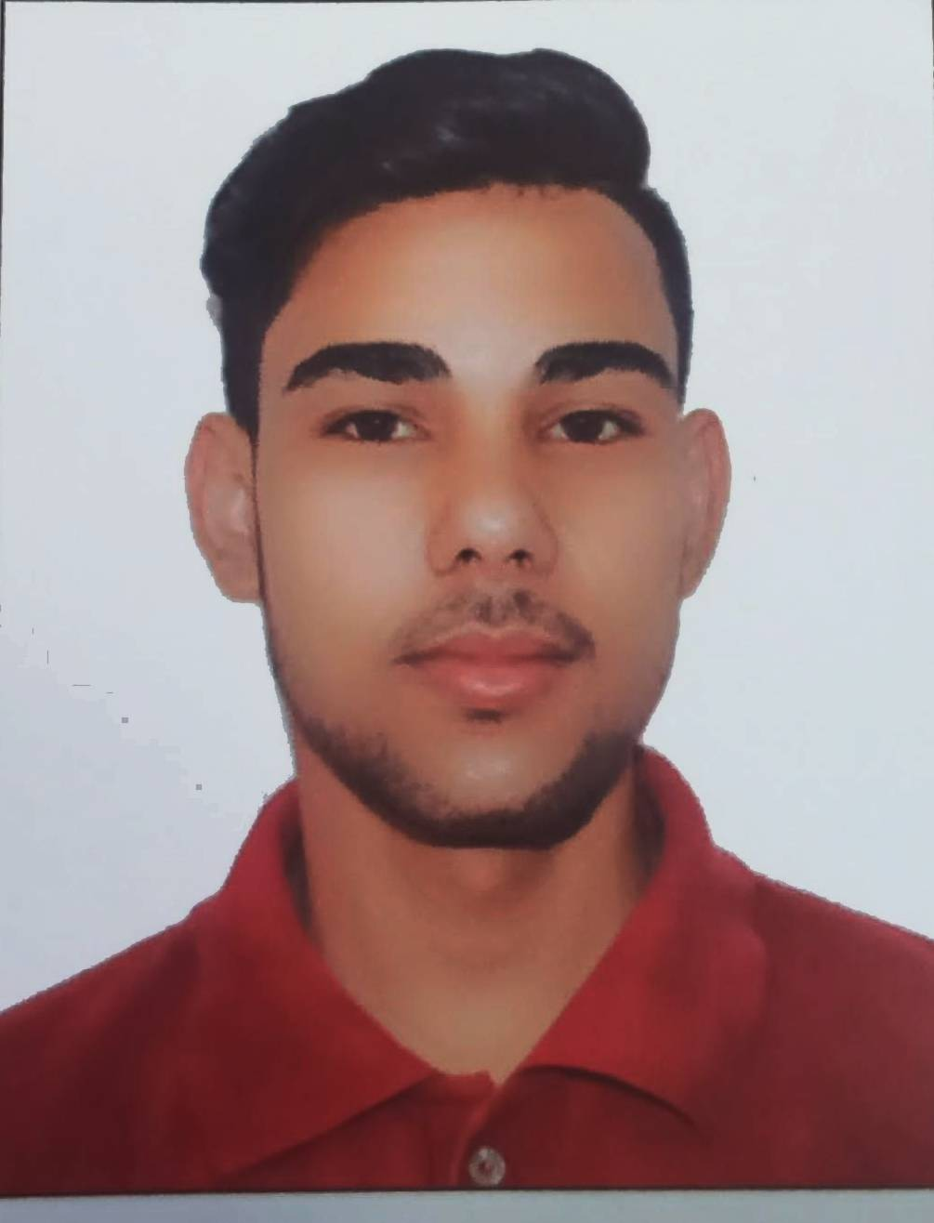

**Mr. Govinda acharya**

Contact No +971582060678

**Email:**  acharyagovinda61@gmail.com

**Date of Birth: - 20th Mar. 2003**

**­**

**Summary:**

* Looking to improve and expands knowledge and skills and to establish an employment in a friendly environment. Enjoy working with all ages and cultures. I'm always on time for work.

**Highlight:**

**Skills:**

|  |  |
| --- | --- |
| * Highly responsible and reliable Upbeat, outgoing and positive * Exceptional interpersonal skills. * Work well under pressure * Self confident. * Positive attitude with communication skills. | * Ability to create a very good team. * Good organizing skill * Cheerful attitude towards work, always presentable. * Can give maximum efforts to do the assigned objectives. * Co-ordination with others. |

**Experience:**

**21th March.2018 to 22 th May2021 : Bakery Chef from The Cafe Kathmandu (Jorpati, Kathmandu, Nepal )**

* Create and prepare all pastry items as required by the business
* Prepare, clean and organize ingredients for use in the kitchen
* Come up with recipe ideas from scratch
* Plan the menu of desserts and pastry to complement savory items
* Ensure the kitchen is clean and sanitized at all times
* Oversee a team of junior pastry cooks and other staff members as necessary
* Maintain up to date knowledge about pastry arts and ingredients
* Carry out administrative duties to maintain an efficient workspace

***Training***

* Basic Computer course.,

(Ms-office Word, Excel, PowerPoint, E-mail Internet)

* Basic Fire Safety Training.

**Qualification**

School Leaving Certificate ( SLC), A Nationwide Board Examination given by the Ministry of Education Nepal, High School Attended:

**Interest and Hobbies**

* Reading Novels
* Traveling
* Playing Chess and Cricket

**Passport Status:** Passport No: 12366274, Expiry Date: 06 SEP. 2031 Place of Issue: Kaverepalanchowk-Nepal

**Personal Details**

Date of Birth : - **20th Mar. 2003**

Permanent Address : - Gotpani,Kavreplanchowk.

Gender : - Male

Nationality : - Nepali

Marital Status : - Single

Languages Known : - English, Hindi and Nepali

**REFERENCES:**

* “MR . Tara Nath Bhattarai

Mob : +977-9861799634

**I hereby declare that the above information given by me is confidential and true to the best of my belief**.