***c***

***URRICULUM***

***ITAE***

***v***

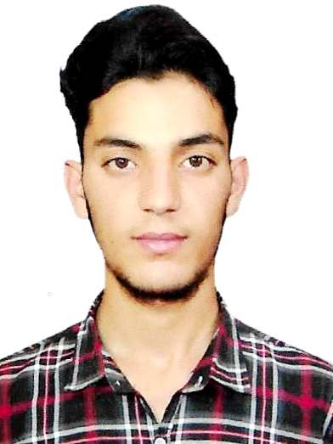

***HABIB KHALID***

* ***+971 58 8976227***

***Dubai UAE***

***Email: Habibkhalid1000@gmail.com***

## *POST APPLIED FOR: “sales Associate ANd HELPER*

## *OBJECTIV:*

A Suitable position with an organization where I can Utilize the best of my skills and abilities that fit to my Education, skills and experience a place where an encouraged and permitted to be an active participant as well vital contribute on development of the Company

## *PERSONAL PROFILES:*

Name : ***HABIB KHALID***

Father’s Name : **Muhammad Khalid Khan**

Date of Birth : 20-11-2001

Nationality : Pakistani

Gender : Male

Religion : Muslim

Marital Status : Single

Languages Known : English, Urdu, Hindi & Punjabi

## *Passport DETAILS:*

Passport No : FP4152861

Date of Issue : 24-08-2022

Date of Expiry : 24-08-2027

Visa Status : **Visit Visa**

## *Education Qualification:*

* ***S.S.C (10th Class)***
* ***03 month Computer Course***

## *personal skills:*

* Good team Spirit and Hard Working Nature
* Punctual focused and very dedicated to any task given
* Expert in performing repetitive tasks speedily and carefully
* Always follow safety rules & regulation

## *EXPERIENCE:*

* **working as a “Sales Associate FMCG ” with Al Kabayel Hypermarket Dubai UAE from 06 months**

**▪ ▪ Worked as a “Sales Associate with CARREFOUR, in Pakistan for the period of (01 years**

## *CONCLUSION & DECLARATION:*

I here by certify that the above mentioned Statement is correct & true to the best of my knowledge & belief.

***HABIB KHALID***