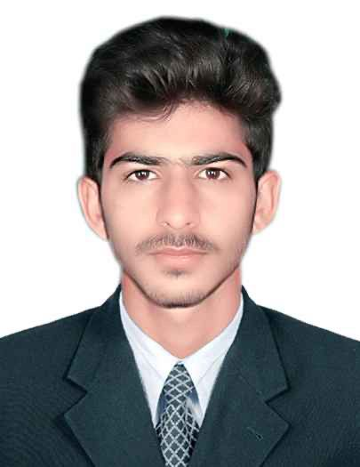 |  | Hamza Pervaiz  Cashier, Computer operator
Profile  Successful managed information using Computer software and Amazon, including sign-in, customer records, orders, and billing with 10% accuracy. Handled incoming and outgoing telephone calls with an overall customer satisfaction core of over 85% in 2019 and 2022.  Preformed administrative and clerical tasks. I am looking for a position in a small or long sized growing firm where I can use my skills to their full potential.  Position Applying for: HR Admin (Document Controller Cashier)  Contact  PHONE:  +92309 1868587  EMAIL:  hamzapervaiz@gmail.com  Hobbies  Social media scrolling  Watching Movies  Cricket  About  Date of birth 10-02-2000  Nationality Pakistan  Religion Muslim  Status Unmarried  Current Status  UAE , Ajman  Visit visa validity 2 months |  | EDUCATION  BOARD OF INTERMEDIATE AND SECONDARY EDUCATION Gujranwala Intermediate  Professional Certification:  • Certified Microsoft Office Pro Main Associates computer institutes  • Computer Operator from Technical Education &Vocational Training Authority ( TEVTA)  WORK EXPERIENCE  Computer Operator / Cashier  1 year work as computer operator and cashier, at Lahore restaurant. Customer care representative  Work experience of 1 year as customer care representative at well reputed company in the area.  Call Centre agent  1 year work as call Centre US based company in Lahore.  Supervisor  1 year work as supervisor in market work also as floor manager.  CORE COMPETENCIES  • Strong leadership, interpersonal, communication & presentation skills.  • Self-motivated.  • Proficient in Technology.  • Problem solving skills.  • Management Collaboration.  SKILLS

