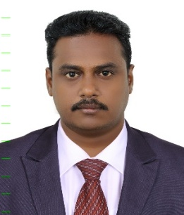 **CURRICULUM VITAE**

**HASSAN ABDUL KADER**

**Contact Mobile Number  : 0501201366**

**E-mail :** hassan.kader86@gmail.com

**Visit Visa Validity : 05-04-2024**

**BUTCHER**

Bringing strong knife skills, customer service abilities along with extensive experience in meat cutting and processing

**HIGHLIGHTS**

* Over 15 years experience as a meat cutter and butcher
* Highly skilled in processing and cutting all kinds of meat including beef, lamb, fish and poultry items
* In-depth knowledge of maintaining appropriate temperatures of meats
* Hands-on experience in operating knife and meat-processing equipment
* Talented in mixing, tenderizing, preparing, weighing and packaging meat products
* Proven record of using hand tools and power equipment to make meat portion control cuts to specification
* Demonstrated ability to maintain high standards of sanitation and personal cleanliness

**WORK EXPERIENCE (15 Years)**

* Butcher Al Maya Super Market, L.L.C, Dubai **(03-05-2017 to 10-12_2023)**
* Butcher, Kharafi Meat Processing Company, Kuwait. **(08-10-2011 to 10-07-2016)**
* Meat Cutter, Sayang Super Market- Penang, Malaysia. **(10-02-2000 to 24-08-2011)**

**EDUCATIONAL QUALIFICATIONS**

* **H.SC,** State Board of Tamilnadu, India.

**WORK RELATED TRAINING CERTIFICATION**

* First Aid Training Course

**COMPUTER LITERACY**

Have working knowledge of

Microsoft Word, Microsoft Excel, Electronic Mail and Internet

**LANGUAGES KNOWN**

English, Tamil, Hindi, Arabic

**PERSONAL DETAILS**

Name : **HASSAN ABDUL KADER**

Father's Name : **Shagul Hamid**

Nationality : **Indian**

Sex & Marital Status : **Male, Married**

Passport Number : **B 9514972**

Visa Status  **: Visit Visa (Valid Up to 05-04-2024)**