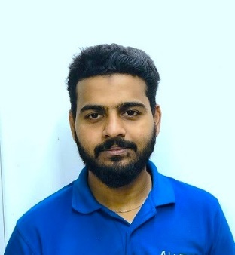

**SSLC**

G.H.S.S. Mogral Puthur, Kasaragod, Kerala, India.

2009

* Meat Cutting & Trimming
* Food Safety & Sanitation
* Inventory Management
* Customer Service
* Time Management
* Stress Management
* Team Spirit
* Adept Language Skills
* Communication

**EDUCATION**

**BUTCHER – Meat Dept.**

*Haram Al Madeena Supermarket, Bur Dubai, Dubai, U.A.E*. */ Feb 2022 – July 2022*

* Cutting, grinding & preparing meats for sale.
* Weighing, packaging, pricing & displaying products.
* Keeping records, Budgets & inventory.

**BUTCHER – Meat Dept.**

*Bismillah Chicken Stall, Kasaragod, Kerala, India. / Jan 2011 – Dec 2021*

* Cleaning, maintaining tools, equipment, ensuring displays, signage are accurate and attractive.
* Receives daily inventory from suppliers & checks against meat ordered.
* Oversees quality of stored meat products
* Assists customers in their concerns & performs custom orders.

**BUTCHER – Seafood Dept.**

*Al Hidaya Supermarket, Bur Dubai, Dubai, U.A.E. / Aug 2022 - Present*

* Maintain high standards for product guidelines in sanitation.
* Maintain high standards of customer service during high volume, fast paced operations.
* Communicated clearly & positively with co-workers & management.

**EXPERIENCE**

A reliable and professional butcher with store management and customer service experience. Specializes in producing clean cuts of meat – poultry, beef, and seafood. A disciplined, organized, and careful worker in handling products and power equipment. Seeking a job in butchery or related roles in foodservice.

**RESUME OBJECTIVE**

**Email:**

[hydaralifort@gmail.com](mailto:hydaralifort@gmail.com)

**Phone:** +971527618957

**Address:** Bur Dubai, Dubai, U.A.E.

**Gender:** Male

**Passport Number:** V7963960

**Language:** Hindi, Malayalam, Kannada, Tamil, Basic English.

**Date of Birth:** 17/Dec/1993

**Religion:** Islam

**Visa Status:** Employment Visa

**SKILLS**

**PERSONAL DETAILS**

HYDARALI. S.M

*Butcher*

Hydarali