  - 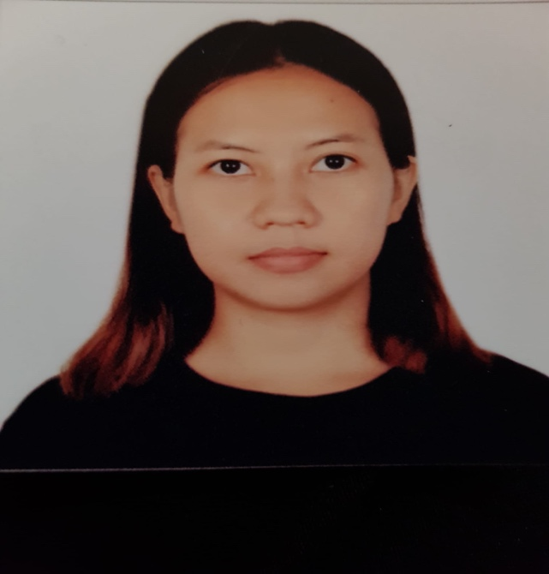
IRISH RABOY

Objective
Finding a good opportunity in a good company that can help me improve my skills, abilities, can increase my practical experience and knowledge, hardworking and enthusiastic. Seeking an opportunity to contribute efficient operation of the front desk by managing multiple tasks, having a positive attitude and demonstrating a high level of professionalism and adaptability.

Contact  Cebu City Philippines  phoenixseverinvon@gmail.com  Contact No. +63 9055578470  Passport No. P0601802  Education  UNIVERSITY of the VISAYAS  Secondary Education  CBD COLLEGE  Bachelor in Elementary Education  Skills  - Communication skills  - Time management and multitasking  - Computer skills  - Problem solving  - Can work under minimal supervision and under pressure  - Customer service/ Front Desk/ Cashiering  - Resourceful |  | Experience  Unique Enterprise – Sales Representative. 2007-2008  Understand customer needs and provide information needed.  Emphasized product features based on analysis of customer’s needs.  Lutana Exporting Company- Office Asst.  Answered the phone and directed incoming calls to the correct individuals.  Organized paperwork, and performed data entry, scanning, printing, sending emails as necessary.  Vapiano Restaurant-FOH Attendant 2017-2024  Preparing bills and registering cash and card receipts, managing customer complaints in efficient manner  Opened and closed the cash desk, sending email reports.  Keep reception area clean and neat to give customers positive first impressions.  Manage phone calls, emails, reservations up selling items and scanning documents.  Dean and David – Cashier cum Receptionist  Managing cash desk, restaurant items, checking expirations and dining facilities.  Handling customer concerns that may arise.  Good communication with the customers and answering inquiries.  Administrative role like scanning, printing documents and email reports.

