**CURRICULAM VITAE**

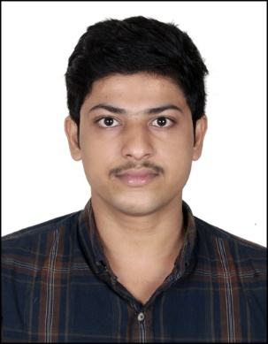**IBIN BABU C**

Chakkalakkal house, Aripalam P.O,

Thrissur-680688, Kerala, India.

Mobile: local contact number: +971 563073015

WhatsApp: +919633689797

Email Id: ibinbabu97@gmail.com

**CAREER OBJECTIVE**

To work in a globally competitive environment on demanding assignments that shall yield the job satisfaction and a steady placed professional growth. Seeking new career challenges and looking to join in a progressive organization that offers opportunities for advancement where I can effectively utilize my professional experience, analytical skill and commitment to perform quality work.

**PERSONAL COMPETENCIES**

* Enthusiastic, Energetic, Adaptable, Patient and Friendly
* Willingness to learn
* Effective communication skills
* Good time management
* Good team player

**EXPERIENCE**

* Worked as a Junior Relationship Officer in Axis bank
* Worked in rig in Qatar offshore

**ACADEMIC QUALIFICATION**

|  |  |  |
| --- | --- | --- |
| Course | Year | Percentage |
| SSLC Kerala State Board | 2013 | 84% |
| +2 Kerala State Board | 2015 | 68% |
| BBA Calicut University | 2021 | 50% |

**OTHER SKILLS**

* Proficient in the use of MS-Office (Word/Excel), Internet & Email communications.
* Familiarity to safety protocols and procedures
* Exposure to working environment which requires flexibility and alertness
* Proficiency in accounting software.
* Ability to prepare financial statements.
* Ability to analyze data.
* Knowledge of general business practice.
* Creating reports using spreadsheets.
* Able to use office equipment like copiers, fax’s, scanners, printers, computers and office software.

**EXPERIENCE**

1. Relationship Officer, Axis Bank, Bangalore Aug 2021 - Nov 2021

Responsibilities:

* Understanding customer concerns.
* Communicating within the company.
* Customer relations.
* Monitoring competitors.
* Time management, multi-task and prioritize work.
* Written and verbal communication.

1. Roastabout, Kuiper, Qatar Jan 2022 - Jan 2023

Responsibilities

* Maintain drilling deck and equipment.
* Prepare drilling equipment for others to use.
* Check pipes for leaks and report them
* Help technicians repair pumps, drills and leaks.
* Operate lifting gear to unload and store supplies and equipment.

**PERSONAL DETAILS**

Father’s Name : Babu Isaac

Date of Birth : 30-10-1997

Passport No : U2754423

Date of Expiry : 18-01-2031

Sex : Male

Religion : Christian

Nationality : Indian

Marital Status : Single

Languages : English, Hindi & Malayalam

**DECLARATION**

I hereby declare that the above information is true and genuine in my belief.

Place: Aripalam **IBIN BABU C**