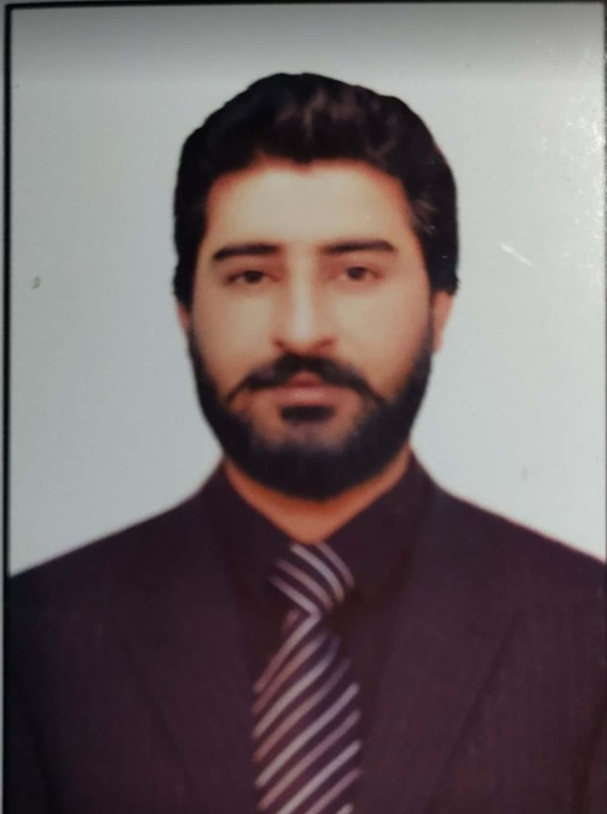
IMRAN ABRO
Mobile No: 056-3081443 & 050-3453381
Email: imiabro12355@gmail.com

Objective:
Ready to work in challenging environment where I can utilize my education and experience for
the mutual benefits.

Working Experience:
Blessed Grow Agriculture and Hydroponic Services LLC- Dubai UAE from Mar-2022 to Present:
Job Responsibilities/Descriptions:
- Place orders and quotes for customers.
- Obtain pricing and request quotes from vendors.
- Assist Sales Leadership with reports and projects.
- Check data accuracy in orders and invoices
- Assist in answering customer calls and sales representative emails.
- Liaise with the Logistics department to ensure timely deliveries
- Maintain and update sales and customer records
- Develop monthly sales reports
- Communicate important feedback from customers internally
- Ensure sales targets are met and report any deviations
- Stay up to date with new products and features

Cashier cum Office Assistant– Jan 2020 to Feb-2022-The Country High School System Larkana Pakistan
Job Responsibilities/Descriptions:
- Collecting cash, cheques and credit card payments and issuing receipts.
- Reconciling daily transactions with day end report and depositing next working day to the bank.
- Performs general administrative duties, like greetings customers and communicating nicely.
- Maintaining and arranging filling in proper sections with right correspondence.
- Ability to work as team and perform the direction accurately.
- Positive attitude, responsible and trustworthy.
- Willing to put an extra efforts & time for the mutual benefits.
Qualifications:
- B. Com (Bachelor of Commerce): Shah Abdul Latif University Government of Pakistan.
Computer & Other Skills:
- Ms-office (world, excel & power point), Internet, Scanning and Fax.

Personal Information:
- Date of Birth : 01 Jan 1997- Single
- Nationality : Pakistani
- Religion : Muslim
- Languages : English, Urdu & Sindhi
- Visa Status : Visit Visa

