**IRAIYILAN R** 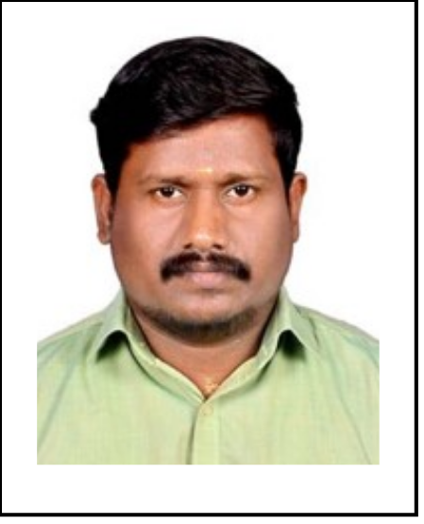

**Phone:** +91- 971 021 6063/+971-552117960

**Mail:** [iraiyilan@gmail.com](mailto:iraiyilanraja1907@gmail.com)

**LinkedIn:** [linkedin.com/in/iraiyilan-r-5b13132a6](https://www.linkedin.com/in/iraiyilan-r-5b13132a6)

**Personal Details**

**Gender:** Male **| Date of Birth:** 19/03/1991 **| Nationality:** Indian

**Address:** Chennai, Tamil Nadu, India

**Profile Snapshot**

* Accomplished professional with over 9 years of experience in banking, financial services, and logistics, skilled in client relationship management and financial service delivery
* Proven expertise in sales and marketing, particularly in account management, loan processing, and investment advisory within the banking sector
* Demonstrated leadership abilities as a team leader, overseeing team coordination, logistics, and warehouse operations in a high-paced environment
* Strong administrative skills, proficient in managing client documentation, financial records, and leveraging CRM and financial analysis tools
* Strategic thinker with a track record of improving operational processes, enhancing customer satisfaction, and driving business growth

**Skill Set**

Client Relationship Management | Sales and Marketing | Financial Service Delivery | Team Leadership and Coordination | Administrative Support | Strategic Planning and Execution | Data Management | Logistics Coordination

**Technical:**

Financial Analysis Tools | Customer Relationship Management (CRM) Software | Microsoft Office Suite

**Professional Experience**

**Jeri Kart Private Ltd. (Flipkart Delivery Partner), India** **Oct 2023 - Present**

**Team Leader**

* Lead and coordinate team activities to ensure efficient shipment segregation and delivery
* Manage warehouse operations, ensuring timely and accurate load pickups and deliveries

**HDFC Bank Ltd., India** **May 2019 - Nov 2022**

**Branch Sales Officer**

* Oversaw savings and current account openings, insurance policies, and various loan services
* Served as an Investment Advisor, providing clients with personalized financial solutions

**Shiksha Financial Services India Pvt Ltd., India Apr 2018 - May 2019**

**Senior Relationship Manager Sales**

* Spearheaded student and school loan processes, enhancing customer satisfaction and loan disbursement efficiency

**Updater Services Pvt Ltd., India** **May 2013 - Mar 2018**

**Office Assistant**

* Managed client documentation and cheque collection, ensuring efficient client service and record-keeping

**Education**

* **Bachelor of Business Administration**, Madras University, India, 2014