

ISMAIL SAIT S/o Basheer Ahamed Sait, 2nd Cross, Tank Mohalla,

Shimoga -577201

[saitismail128@gmail.com](mailto:Saitismail128@gmail.com)

# +971 556414928

Currently in Abu Dhabi, UAE on a Torist VISA – Tel No: +971 556414928

Zone 12, Mohammed Bin Zayed City, Abu Dhabi.

**Objectives**

**To utilize my skills in challenging environments and expand knowledge through**

**Working with new technologies and systems seeking assignments as L2 Systems Support Engineer.**

* Hewlett-Packard GlobalSoft Limited, Bangalore. Providing Microsoft Windows NT 4.0, 2000, 2003, 2008 Server and HP Hardware Support. Supporting Enterprise clients in USA and CANADA Data Centers (remote support 24/7) Support. Worked on Microsoft Windows Server, HP Servers including HP Blade servers and HP Network Support. In-depth knowledge in Wintel and Virtualization, Fault Tolerance and worked on many technologies like Microsoft. Worked in ITIL environment on Incident, Problem, Change and Capacitg management. 8 Years 9 Months of experience in Managing DataCenters remotely.

**Career Synopsis**

**Organization: Hewlett-Packard GlobalSoft Limited.**

**Role: ITO Svc Delivery Cons III, ITO Svc Delivery Cons II**

**(13-09-2011-07-03 2014) (13-06-2005–01-09 2011)**

**Duration: 8 Years 9 Months**

**Client: USA and CANADA based clients**

**Work Location: HP Avenue, 39/ 40, Konapana Agrahara,**

**Electronics City, Phase 2, Hosur Road,**

**Bangalore – 561229, Karnataka, India**

* Supporting Microsoft Windows NT 4.0, 2000, 2003 and 2008 servers for Enterprise clients in USA and CANADA.
* Prior to L3 role, worked in HP as L2 ( Wintel Administrator Level 2), working on Active Directory, DNS, DHCP, WINS, Performance Issue, OS Debugging by analyzing memory dump, MS Cluster, File Server, Print Server, Server Build, Virtualization, Terminal Servers, MS Security Updates, Security Compliance Audit.
* Working RAID with SAN Team in case of any disk extension or new Lun addition.
* Adding Servers into the Rack, Adding Disks, Memory, into the Blade Servers.
* Installation of Microsoft Windows Server 2000, 2003, 2008 remotely.
* Adding Disk Controllers, iLo Cards, Configuring RAID 1,RAID 2,RAID 3, RAID 4,RAID 5.
* VMware Server, Creating Virtual Machine, Adding Disk, Memory.
* VSphere, P2V Server Migration, Moving Resources, Trouble shooting.
* VMware Clusters, Cluster Failover, Creating Resources, Patching and Rebooting Cluster Servers. Bringing Cluster Resources Online. Creating Scheduled Tasks.
* Experience on Active directory, Server Administration at an enterprise level.
* Mass deployment of Microsoft patches using WSUS, Update Expert and Shavlink.
* Backup using NetBackup, Veritas, Tivoli. HP Data Protector.
* Cluster Server Patching, Troubleshooting MS Clusters.
* Auditing servers, and executing PSP and Firmware upgrade end to end activity to make compliance. Hardware Diagnostic tools, Bringing Servers Online with iLo.
* Providing Remote support to 27 US Based Customer in shared delivery having 2000+ Servers.
* Providing Solutions if any alerts observed by NOC Team, Open ticket in remedy server for Windows Team. As per SLA need to resolve the incident.
* Performance Monitoring.
* Providing solution as per the SLA in 24x7 environment to keep the infrastructure stable, Handling customer calls meeting SLA requirements.
* Owned several transitions of Projects from Onshore to Offshore.
* Ensuring documents are up-to-date related to delivery and Creation of SPOC.
* Taking monthly incident review and working on creating PR to reduce the tickets in delivery wherever needed.
* Working with network and Firewall team if any issue.
* We Support Fortune 500 companies of US and CANADA region that include financial services companies.
* Managing L1 and L2 Team and working on the tickets escalated by L1 and L2.
* Creation of Problem tickets as proactive task to reduce the incident tickets in the delivery on the basis of monthly incident report taken by us being as SPOC for our customer.
* Managing a Team of Engineers, supporting internal infrastructure, remote site and external customers.
* Managing Team and Train the new joiners.
* Worked only on P1 and P2 escalated issues and provide solutions.
* Worked on CIP (Continuous Improvement Process) for the identified customers where we find the scope.
* Creation, managing and ensuring all documents are up-to-date for the clients, designated as SPOC for particular customers.
* Creation of KEDB on the basis of experience of PR handled and resolved
* Worked with different team for SAN, Network, Firewall and Backup issues.
* Worked on Capacity Management, Problem Management, Incident Management and Change Management.
* Worked on RCA and Present it to the customer. Attend CAB/TAB Meeting, Prepare Change and CIP.
* Worked on various tools (Inbuilt with Sysinternals and third party tools )
* Have very good experience of people management as managed 20+ people team of L1.

**Projects assignments and responsibilities:**

* Building Windows 2000, 2003 and 2008 Servers.
* Creating and managing Users, Shares and DFS pointers.
* Managing MS Clusters, Patching of Servers including Clusters Servers.
* Managing Backup and Restore using Veritas, HP Data protector.
* Managing Norton Antivirus Corporation Edition.
* Audit servers for security compliance and provide solution.

**Awards and Recognition in Hewlett-Packard.**

* **Ensured a smooth and successful KT and pilot phase for Major Client operations from RMC. RMC Head Onshore ‘’The responsibility and dedication shown in addition to the routine operational activities is appreciated’’**

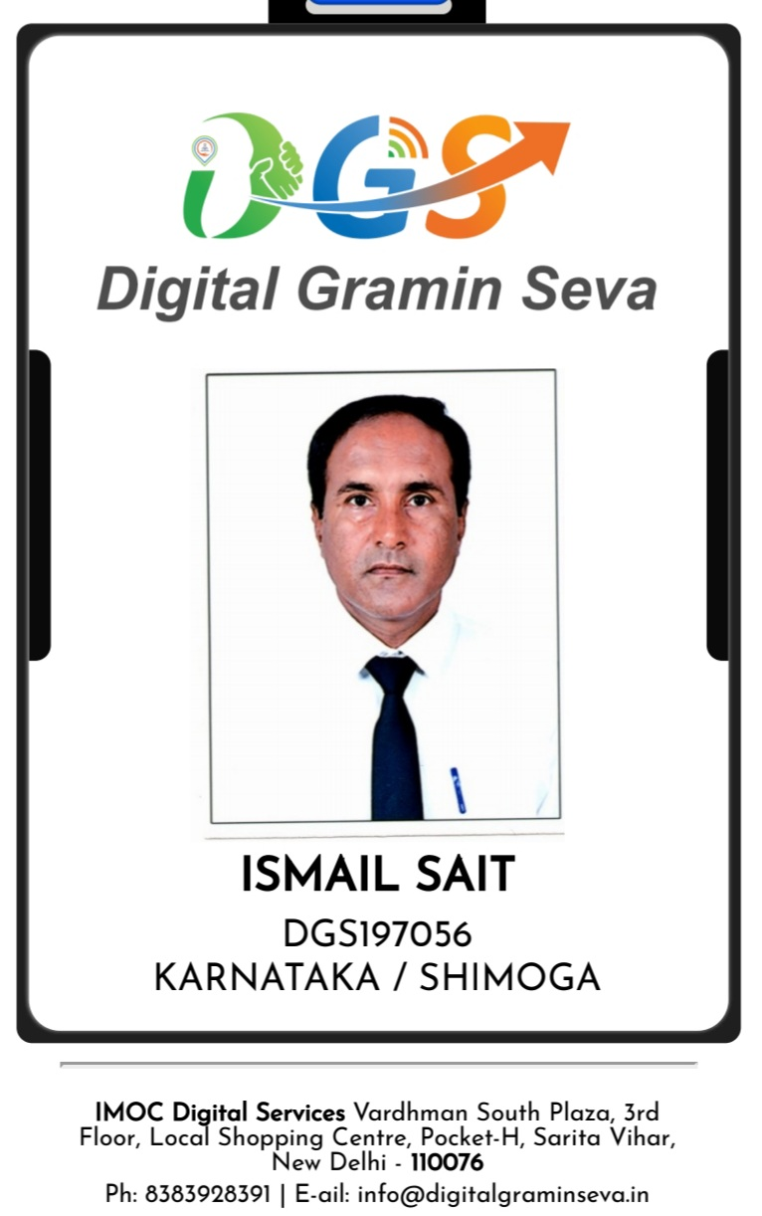

Ismail Sait

S/o Basheer Ahmed Sait,

AYESHA MANZIL,

10th CROSS, 1st STAGE, DR RML NAGAR,

Shivamogga - 577202,

Karnataka, INDIA.

**Personal Details**

Father’s Name: Basheer Ahmed Sait

Date Of Birth , Age: 28-06-1975 , 49 years

Marital Status : Unmarried

Health Status: 19-05-1989 Injured in BUS ACCIDENT

Karnataka State Road Transport Corporation BUS ACCIDENT

BANAVARA, KARNATAKA, INDIA

PAN CARD: AATPI5382

AADHAAR CARD: 3196 2276 8432

Passport number: C 3071906

Date of Issue: 09-10-2024

Date of Expiry: 08-10-2034

Mobile Number: 7204191243

**Technical and Global Certifications**

* **Microsoft Certified Professional (MS Windows NT Servers )**
* **Microsoft Certified System Engineer. (MS Windows Server 2000)**
* **Microsoft Certified System Engineer. (MS Windows Server 2003)**
* **Cisco Certified Network Associates ( CCNA)**

**Cisco Certification ( TOP GUN Institute, Rajajj Nagar, Bangalore )**

**Academic Qualifications**

* **Master In Computer Application, ( Deemed University)**

**( Jan 2007 – Dec 2009 )**

**Institute Of Advanced Studies in Education University**

**Gandhi Vidya Mandir Sardarshahr - 331401, Rajasthan, India.**

**( Jan 2007 – Dec 2009), Bellary, Karnataka, India.**

* **Certificate in Computing ( Jan 2002 - July 2002 )**

**Indira Gandhi National Open University,**

**Maidan Garhi, New Delhi - 110068, India.**

**( Jan 2002 - July 2002 ) Vijaya College, Jayanagar 4th Block,**

**Bangalore, Karnataka, India.**

* **Bachelor of Science ( Chemistry, Botany, Zoology)**

**( June 1994 – Apr 1998 ) Sahyadri Science College,**

**Vidya Nagar, Shimoga – 577201, Karnataka, India.**

**Kuvempu University, Jnana Sahyadri,**

**Shankaraghatta – 577451, Shimoga. Karnataka, India.**

* **Pre – University EDUCATION, GOVERNMENT OF KARNATAKA**

**National Pre- University College, ( 27-06-1992 to 27-05-1994 )**

**( Physics, Chemistry, Mathematics, Biology)**

**National Education Society, Balaraj Urs Road**

**Shimoga- 577201, Karnataka, India.**

* **KARNATAKA SECONDARY EDUCATION EXAMINATION BOARD**

**D.V.S High School (Apr – 1988 to Apr - 1992)**

**Sir. M.V. Road, Basaveshwara Circle**

**Shimoga – 577201, Karnataka, India.**

* **D.V.S Higher Primary School (Apr – 1985 to Apr - 1988 )**

**Sir. M.V Road, Basaveshwara Circle, Shimoga- 577201, Karnataka, India.**

* **D.V.S Primary School ( Apr – 1980 to Apr – 1984 )**

**Sir. M.V Road, Basaveshwara Circle, Shimoga- 577201, Karnataka, India.**

**Organization: Maini Info Solutions Pvt. Ltd. Mc Grath Road,**

**Asok Nagar, Bangalore – 560010**

**Role: System Administrator**

**Duration: Oct 2004 to June 2005**

**Job Responsibilities:**

* Installing and Configuring Active Director and DNS.
* Installing and Configuring DHCP and WINS.
* Installing and Configuring Exchange Server.
* Implementation of Anti-Virus Server.
* Implementation of Proxy Server Internet Access.
* Installing and Configuring File Server and Print Server.
* Configuring and maintaining Ghost Server and Images.
* Configuring Hardware RAID and Troubleshooting.
* Testing and monitoring of lease line and ISDN for smooth function of Network.
* Configuring and maintaining Lease Line Circuits.
* Interacting with Service Provider to resolve issues.
* Vendor management in purchasing and resolving the issues.
* Monitoring Lease Line.
* Assisting Desktop Support team.
* Worked on remote software like Dame Ware and VNC.
* Assisted in the development of defining the scope and nature of appropriate technology for the office. This included the managing of the migration of the PC workstations from Windows 95/98.
* Installation and configuration of Antivirus server (Symantec) and clients.
* Installation, configuration and maintenance of line printers, local and network printers etc.
* Responsible for the daily operation, monitoring, troubleshooting, and maintenance of the Local Area Network (LAN) and desktop support.
* Monitoring of servers.

**Organization: S.B.M.S.I.T Nelamangala, Bangalore Rural - 562123**

**Role: Systems Analyst**

# Duration: Feb 2001 to Oct 2004

**Job Responsibilities:**

* Ghosting Windows Operating Systems.
* Configuring and maintaining Ghost Server and Images.
* Installing Microsoft Back Office products.
* Installing Anti-virus clients.
* Troubleshooting outlook and outlook express.
* Basic administration of Vlan.

1. Implementation of printer servers.
2. Worked on remote control software’s like Dame Ware, VNC.
3. Installation and configuration of database software’s like oracle client.
4. Taking file server backup.
5. nstallation and configuration of Antivirus server (Symantec) and clients.

* In nstallation and configuration of Antivirus server (Symantec) and clients.
* Installation, configuration and maintenance of line printers, local and network printers etc.
* Responsible for the daily operation, monitoring, troubleshooting, and maintenance of the Local Area Network (LAN) and desktop support.
* Monitoring of servers.

**Organization: Infinity Infotech, Near to B.B.M.P Office,**

**T Dasara Halli, Bangalore - 560057**

**Role: Computer Faculty ,**

# Duration: Oct 2000 to Feb 2001

**Job Responsibilities:**

* Ghosting Windows Operating Systems.
* Configuring and maintaining Ghost Server and Images.
* Installing Microsoft Back Office products.
* Installing Anti-virus clients.
* Troubleshooting outlook and outlook express.
* Basic administration of Vlan.

1. Implementation of printer servers.
2. Worked on remote control software’s like Dame Ware, VNC.
3. Installation and configuration of database software’s like oracle client.
4. Taking file server backup.
5. nstallation and configuration of Antivirus server (Symantec) and clients.

* In nstallation and configuration of Antivirus server (Symantec) and clients.
* Installation, configuration and maintenance of line printers, local and network printers etc.
* Responsible for the daily operation, monitoring, troubleshooting, and maintenance of the Local Area Network (LAN) and desktop support.
* Monitoring of servers.

**Organization: Silitech Systems, Bangalore.**

**Role: Computer Hardware Technician,**

# Duration: Feb 2000 to Oct 2000

**Job Responsibilities:**

* Computer Assembling, Installation of Windows 3.5, Windows 95, Windows 98, Hardware troubleshooting, Visiting customer places, configuring Modem, Internet connection troubleshooting Ghosting Windows Operating Systems.
* Configuring and maintaining Ghost Server and Images.
* Installing Microsoft Back Office products.
* Installing Anti-virus clients.
* Troubleshooting outlook and outlook express.
* Basic administration of Vlan.

1. Implementation of printer servers.
2. Taking file server backup.
3. Installation and configuration of Antivirus server (Symantec) and clients.
4. Installation and configuration of Antivirus server (Symantec) and clients.

**Organization: Computer Software Of India, Gandhi Nagar, Shimoga.**

**Role: Computer Faculty ,**

# Duration: Feb 1999 to Jan 2000

**Job Responsibilities:**

* Teaching MS - DOS Operating Systems.
* Microsoft Windows 3,1, Windows 95, Windows 98.
* Microsoft - WORD, Microsoft - EXCEL,
* Microsoft - POWERPOINT, Microsoft - Access.

**Current Working Status**

Computer Hardware Centre: Plot No- 06, SAIT ENGINEERING WORKS,

K.I.A.D.B DEVAKATHIKOPPA AUTO-COMPLEX,

KIADB INDUSTRIAL AREA, DEVAKATHIKOPPA,

Shimoga- 577204, Karnataka, India.

**Role: Computer Hardware Technician**

# Duration: Dec 2019 to Till Date .

**Job Responsibilities**

* Configuring, Upgrading Operating Systems, Upgrading BIOS.
* Configuring Disks, NIC, Display, Audio Drivers.
* Installing and Configuring LAN, Configuring Printers, Network Printers.
* Configuring of Anti-Virus Server, Clients.
* Visiting Customer Places maintenance of the Local Area Network (LAN) and desktop support.