**Curriculum Vitae**

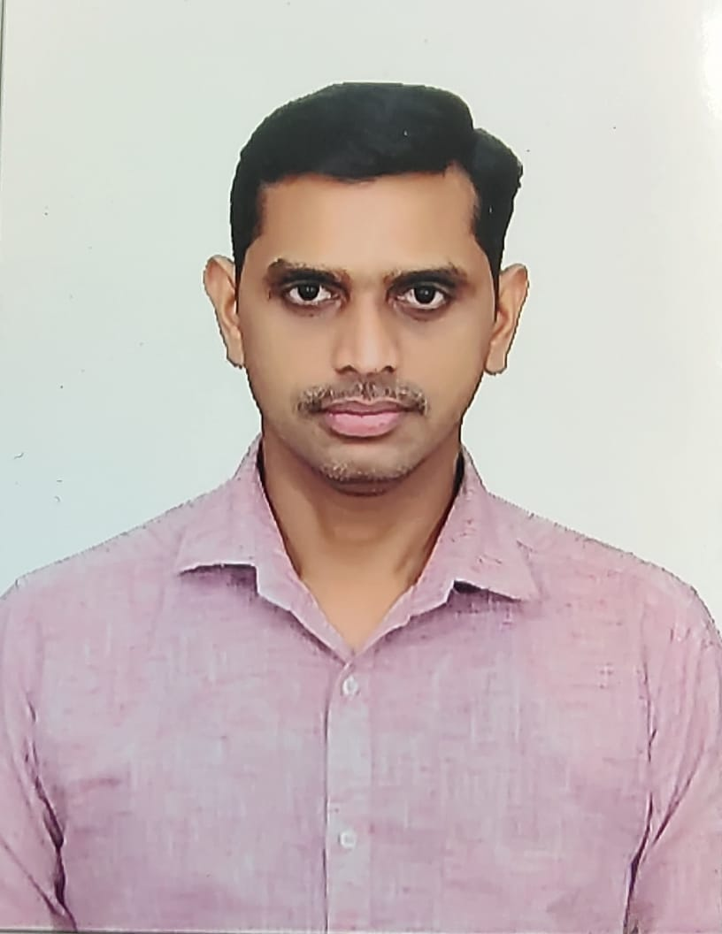**JALEEL k**

Flat No 302, Ashraf Building,   
Al Nabba, Sharjah.   
Mobile: +971 52 279 7924.

E-mail: jaleel.k36@gmail.com

**OBJECTIVE**

*To work in a challenging and responsible position where my professional background can be utilized for the progress of the organization and to update myself with the Latest technologies, so as to enable myself to establish in future.*

**SUMMARY:**

* Well-organized, efficient, quick learner, self-motivated.
* Ability to plan, organize and prioritize work.
* Analytical and innovative in problem solving.

**EDUCATIONAL QUALIFICATION**

* D.E.E.E. {Aalim Mohammed Salegh Polytechnic College}

**IT SKILLS**

* MS-Office, Tally & SAP.

**CAREER SKILLS:**

* Inbound & Outbound Activities
* Inventory
* Internal Audits
* Shelving
* Transport Management
* Customer Relationship Management
* Problem Identification & Solving
* Customer Focused Service

**PROFESSIONAL EXPERIENCE**

Company : Reliance Jio Mart  
Position : Assistant Manager - Operations  
Period : 2nd May 2022 to 8th Feb 2023.

Company : Khazana Jewellery Pvt Ltd  
Position : Sr Executive – Warehouse Operations  
Period : 23rd January 2017 to 20th April 2022.

Company : Khazana Jewellery Pvt Ltd. Position : Assistant Manager – Sales & Admin Period : 12th August 2011 to 30th September 2016.

Company : Al Sahra Heavy Equipments. (**UAE**)  
Position : Electrical Foreman. (Admin & Stores)   
Period : 28th December 2007 to 20th November 2009.

Company : Eveready Industries India ltd,   
Position : Technical Officer.   
Period : 23rd August 2006 to 19th December 2007.

**JOB DESCRIPTION**

* **Handling 40000 square feet warehouse with 60 manpowers and 3000 sku’s.**
* **Overall responsible for warehouse operations,**
* **Maintaining 100% stock accuracy.**
* **Reporting to management on daily activities and achieving day-to-day targets.**
* **Maintain the fill rate 100% on daily dispatches.**
* **Proper stacking as per storing norms and following FIFO method.**
* **To issue materials only in required quantities against authorized requisition material list.**
* **Follow up materials in stores under FIFO basis and dispatch the materials.**
* **Classifying inventory in to fast moving, non-moving & slow moving.**
* **Preparing Inbound and outbound documents.**
* **Co-ordinate with Head office team and Showroom for dispatch priority plan.**
* **Follow up with Vendors regularly and getting materials with in Time.**
* **Good knowledge in Store Related activities such as Material Receiving, Issuing, Stock Maintaining, Cost cutting in storage area.**
* **Restructured the packing area, which facilitated the picking and packing process.**
* **Preparing MIS reports as per the need of management.**

**PERSONAL PROFILE**

**Name : Jaleel K**

**Fathers Name : Kassim**

**Date of Birth : 26 -4 1987**

**Nationality : Indian**

**Marital Status : Married.**

**Passport No : N 9353525**

**Languages Known : English, Tamil, Hindi, Malayalam & Urdu,**

***I hereby declare that above details are true correct with best of my knowledge and belief.***

*Jaleel.k Date:*