RESUME
JAYANTH VR
E-mail ID : jayanth474@gmail.com Mobile No: 00971- 569659435
: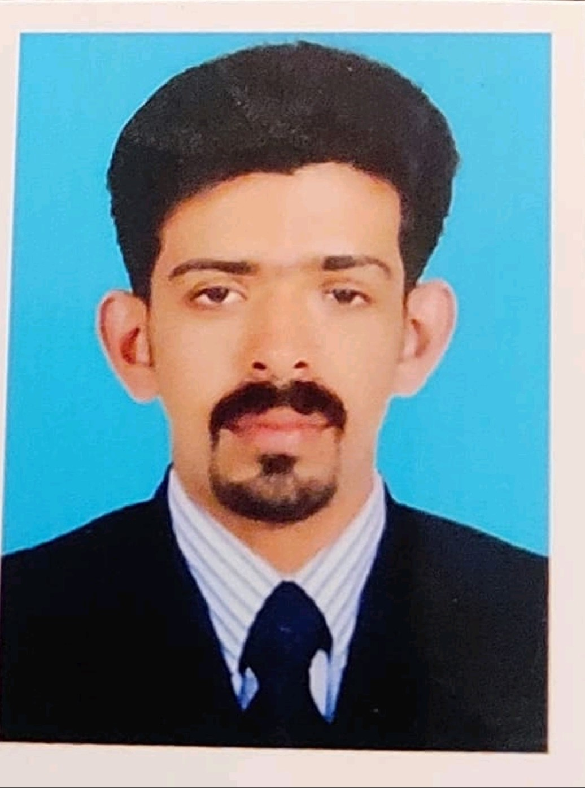
PERSONAL DATA:
Name : Jayanth V. R Father's Name : Rajendra Prasad Mother’s Name: Suja Mani. S
Age : 33 (23/07/1990)
Sex : Male
Marital Status : Married Nationality : Indian
Religion : Hindu

LinkedIn Profile: www.linkedin.com/in/jayanth-vr-022844121

PERMANENT ADDRESS:

VIDYA BHAVAN (H) ANIKADU.P.O KAYOORI- 686503 KOTTAYAM, KERALA.

OBJECTIVE
Seeking a suitable position in a challenging environment wherein my skills and professional qualification can be utilized towards professional growth and development of the company and myself.

PROFESSIONAL QUALIFICATIONS

MBA HUMAN RESOURCE MANAGEMENT from
Bharathiar university, Coimbatore, Tamil Nadu, India

B.sc HOTEL MANAGEMENT AND TOURISM from
Annamalai University, Chidambaram, Tamil Nadu, India

SKILLS
Languages Known : English, Malayalam, Tamil Oral Fluency : English, Malayalam, Tamil Written Fluency : English, Malayalam

AREAS OF INTEREST

- Sales & Marketing

- HR & Administration

PASSPORT DETAILS:
Passport number: M3705124 | Date of issue | : 25/11/2014
Date of Expiry : 24/11/2024 | Place of issue | : COCHIN

ABILITIES

        - Ability to handle good relationship with customer.
        - Ability to understand customer.
        - Make others to achieve their targets.
        - Can Making strategies.
        - Team Management
        - Sales and Marketing
        - Oral Communication
        - Problem Solving

EDUCATIONAL QUALIFICATIONS

COURSE | UNIVERSITY/BOARD | YEAR OF PASSING
M.B.A Degree | Bharathiar University,  Coimbatore, Tamil Nadu, India | 2014
B.sc Degree | Annamalai University Tamil Nadu, India | 2011
H.S.E - XII | Board of Higher Secondary  Examination, Kerala State | 2008
S.S.L.C - X | Board of public examination Kerala | 2006

TRAINING & EXPERIENCE

NAME OF INSTITUTION | POSITION | DESCRIBTION | DURATION
Punarjani Ayurvedic | Marketing Executive | Marketing | 10/05/2014 to
Resorts Pvt. Ltd |  |  | 01/09/2015
Ramakkalmeddu
Muthoot Fincorp Pvt Ltd | Customer service | Marketing | 10-09-2015 to
 | Executive |  | 03-08-2016
HDFC Sales Pvt Ltd | Relationship Officer | Marketing | 17-08-2016-
 |  |  | 28-02-2018
FSquareCochin | Sn Marketing Executive | Marketing | 05-03-2018 to
Hotels |  |  | 01-03-2019
Esaf small finance | Sn. Sales officers | Home Loan, Auto loan, | 04-12-2019 –
Bank LTD |  | personal loan, casa, LI, GI  , Collection | 19/12/2023

TECHNICAL QUALIFICATION

NATIONAL COUNCIL FOR VOCATIONAL TRAINING(N.C.V.T) Passed in Assistant
Steward/Waiter/Barmen Under Hospitality assessed by KITCO LTD.

REFERENCES

ACADEMIC : Dr. M George Sebastian M.Com., Ph.D. Principal Bright Institute, Pala Kottayam, Kerala, India

PH: 04822214082, 09447567992
PROFESSIONAL : Mrs. Anju Raveendran,
Branch Manager Muthoot Fincorp Kottyam Kerala, IndiaPH:8075382152
: Mr.Mejin J vattakunnel
Area Sales Manager Esaf small finance bank Ltd PH 94973198

DECLARATION

I hereby declare that the above made statements are true to the best of my knowledge and belief.

Place: Kodungoor
Date : JAYANTH

