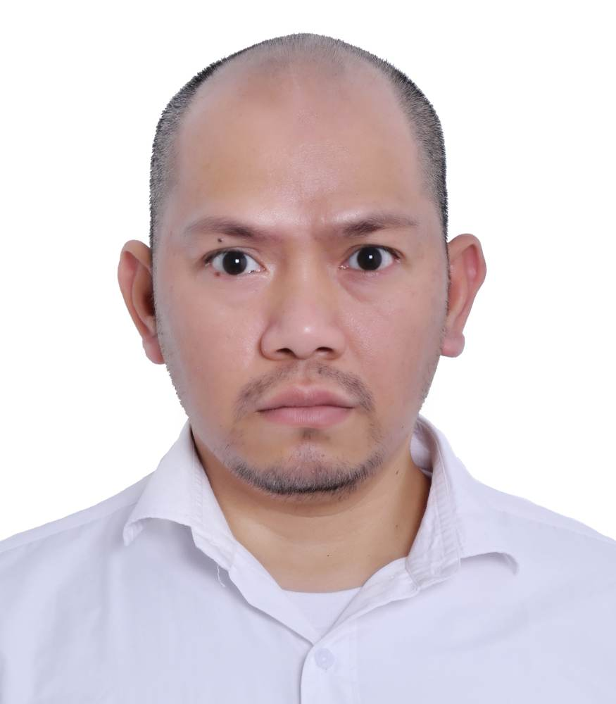

JOHN PAUL B. MARTINEZ

Mobile no: +971-552391382

Whatsapp no: +971-552391382

Email add: [Jipz19.jpm@gmail.com](mailto:Jipz19.jpm@gmail.com)

**CAREER RELATED SKILLS**

* Handling data entries and duties with care
* Good communication and interpersonal skills
* Good team-player who’s detail-oriented
* Well-versed in Microsoft Office
* Knowledge in AutoCAD and Adobe Illustrator
* Knowledge in plastic Injection molding machine
* Knowledge in Organize files
* Knowledge in ERP System
* Knowledge in sketch-up

**CAREER OBJECTIVES**

* To pursue a challenging career with dedication and provide my efficiency to the fullest in a professional organize at career environment wherever I serve my duties that will discover my potential in me.

**EDUCATIONAL INFORMATION**

|  |  |  |
| --- | --- | --- |
| **Years Attended** | **Name of School** | **Course** |
| 1999-2002 | Philippine Science and Technology Center | Diploma in Computer Technician |

**EMPLOYMENT INFORMATION**

* **BRAIN FREEZE INTERIOR AND DECORATION (DUBAI,UNITED ARAB EMIRATES)**

**Position: Office Assistant**

**Date: Dec. 2022-Present**

**Duties and Responsibilities**

* I Manage of answering the phone calls if it is needed.
* I do Organize the files and materials in the office.
* I do Prepare the coffee to my General Manager and guest.
* I do Preform as a Receptionist and given assistance with my office staff if they need it.
* Managed of facing some deliveries coming and receiving voucher.
* I do to give assistance in Procurement and admin staff to make work fast.
* I do AutoCAD and sketch-up in designer department furniture.
* I do of facing suppliers to receive catalogs and samples.
* **JR. Plastic mfg. corporation (Philippines)**

**Position: CAD Operator/Injection Supervisor**

**Date: Aug 2017-Oct 2017**

**Duties and Responsibilities**

* I do in AutoCAD design department
* I do encode production output and submitted production report to Production Manager
* I Managed to Supervise the Production Operation.
* Managed in Making a monthly presentation in Production Performance.
* **Dohyun Protect CO.LTD. (South Korea)**

**Position: Team leader/Warehouse helper**

**Date: Sept 2008 – Aug 2016**

**Duties and Responsibilities**

* Managed in the operation of the plastic injection molding machine used for molding reﬂector products used in road signs.
* Managed to Supervisor of the team in the production line.
* I do Encode the production output and submitted the production report to Production Manager.
* Manage to Helping the warehousemen to unload and load the production
* **Deasan Curve CO.LTD. (South Korea)**

**Position: Operator Machine/Warehouse helper**

**Date: Jan 2006 – Jan 2008**

**Duties and Responsibilities**

* I do Helping the warehousemen to Load and Unload the product in Cargo.
* Managed in operating the Computer Numeric Controlled (CNC) machine for wood curving and drilling furniture.
* I do of changing the drill bits used in the CNC machine.

**TRAININGS & SEMINARS**

|  |  |  |
| --- | --- | --- |
| **Date** | **Training / Seminar Title** | **Presided By** |
| Mar.28,2001 | Micro Computer Technology | PSTC |
| May 14,2001 | Technician on Surplus(OJT) | Jaka Plaza |
|  | System Standard Inc.(OJT) | Makati |

**LICENSES AND CERTIFICATIONS**

|  |  |  |
| --- | --- | --- |
| **Name of License / Certiﬁcate Title** | **License / Certiﬁcate #** | **Validity** |
| AUTOCAD and FUSION | 1IVALHNN21 |  |
| Computer Technician | 011316040599 | sept.18,2007 |