Kaung Set Wai

**Customer Service Representative**

**Phone:** 0567780764 **Email:** kaungsw@gmail.com

**Address:** Room 504, Food valley restaurant building, Bal’urouq st , Abu Dhabi

Dear Recruiter Group,

I'd like to apply for the position of Customer Service Representative that is currently advertised on your company's website. Please see my accompanying resume for a more detailed description of my work history and achievements.

I worked for Telenor Mobile Operator as a customer service representative and Ocean Wave Communication Company Limited as a quality auditor. I managed both incoming and outgoing calls. I've handled with requests, complaints, and enquiries from clients for almost five years. While responding to the customer, I concurrently upsold the products. As a quality auditor, I conducted training for junior and new employees.

My background in the customer support industry has equipped me with outstanding organizational skills and problem-solving skills. And I am thrilled to offer my talents and teamwork skills to your team's efforts. This experience, together with my interpersonal and organizational skills, makes me the perfect candidate for establishing a long-term career in this field.

I would appreciate the opportunity to interview as soon as possible. Thank you for taking the time to review my candidacy.

Sincerely,

Kaung Set Wai

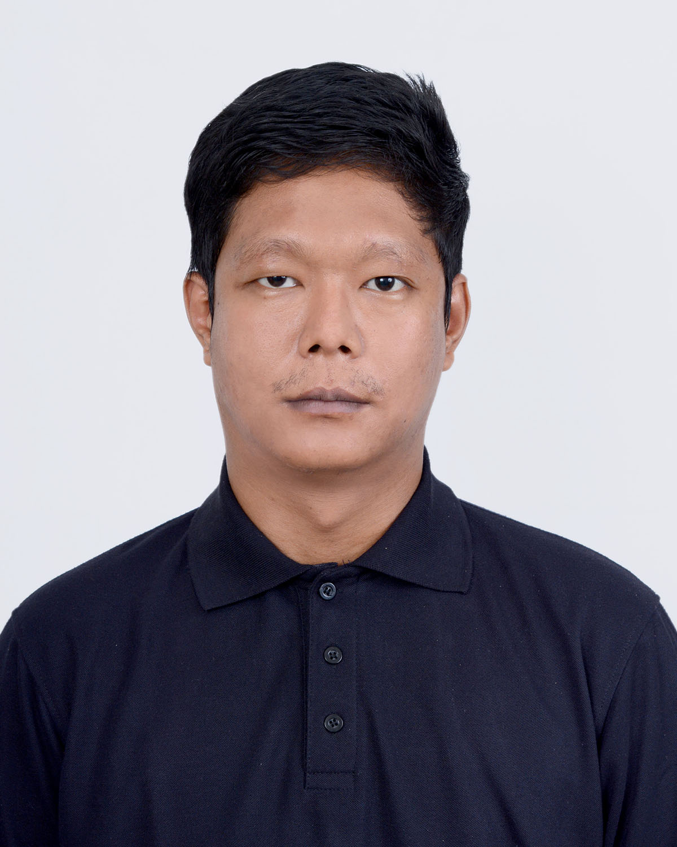

M

Kaung Set Wai

**Customer Service Representative**

**WORK EXPERIENCE**

**Customer Service Representative at Telenor Myanmar Operator (Telecommunications)**

**Jun-2016 to Apr-2019 (2 years & 10 months)**

* Working day and night shifts in a rotating system
* The details of each calls are carefully noted
* Follow up on the serious complaints with the concerned departments
* Upselling the product while responding to the customer.

**Quality Auditor** **at** **Ocean Wave Communication Company Limited (Internet Service Provider- Myanmar)**

**Jan-2022 to Oct-2023 (1 years & 10 months)**

* Listening to the daily call recording of the agent as a quality auditor
* Providing up-to-date information to the inbound agents and outbound agents and online customer service agent
* Managing customer concerns through communication with Supervisors, Team Leaders , Quality Auditors and staff
* Preparing report daily, Weekly and monthly

Always dedicates to work, want to complete the job in the best way.

Solid knowledge and high sense of responsibility.

Able to work in a high pressure environment, always willing to learn and self-develop.

**KEY SKILLS**

* Excellent Communication
* Organization skills
* Upselling
* Problem Solving
* Documentation

**EDUCATION**

* **Basic Education High School, Myanmar**

2011 High School Diploma

* **YADANABON UNIVERSITY, Myanmar**

2019 Bachelors’ Degree (English)

**PERSONAL DETAILS**

* **Date of birth**

16-Apr-1995 (28 years)

* **Nationality _** Myanmar
* **Language**

English, Burmese

* **Address**

Room 504, Food valley restaurant building, Bal’urouq st, Abu Dhabi

* **Contact**

kaungsw@gmail.com

0567780764