



**LIZEL Q.QUIZON**

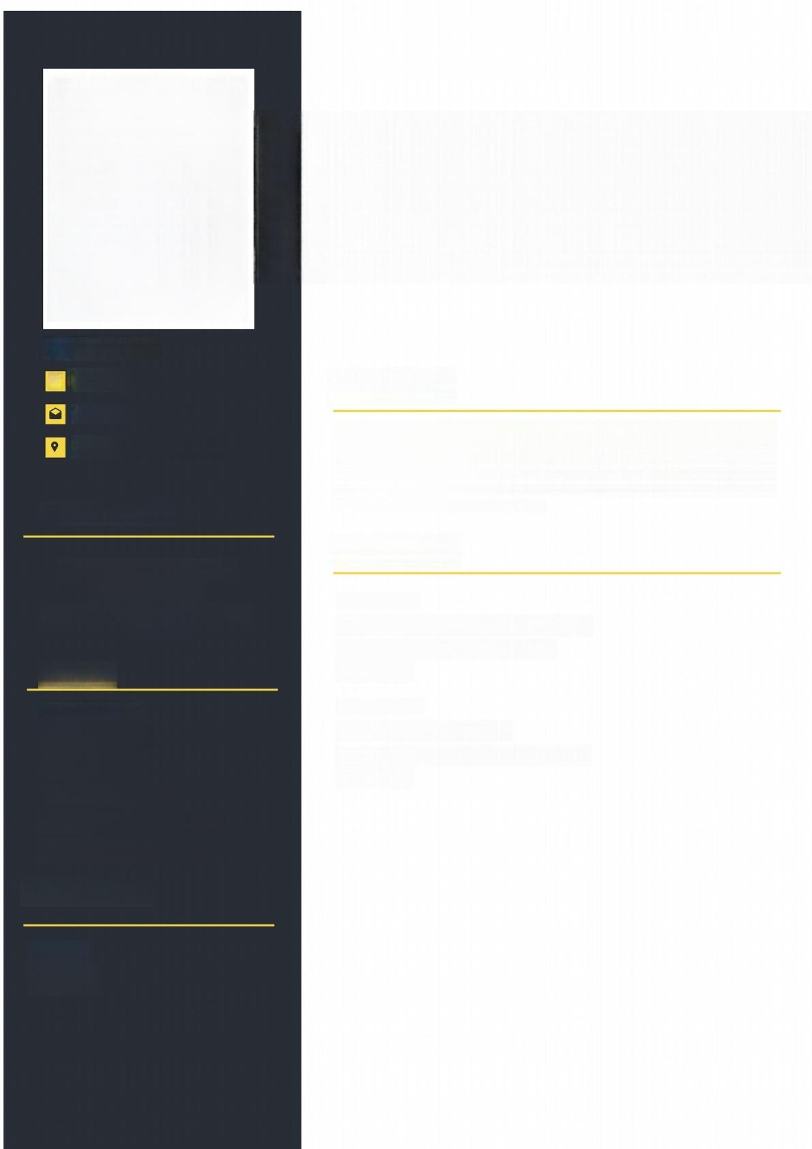**CONTACT**

L 09655331206

lizelquizon052l.com

Batal Santiago City,Isabela

**EDUCATION**

**Business Information**

**Management**

AMA Computer Learning Center

2001-2003

**SKILLS**

·Teamwork

● Adaptability

·Initiative

·Microsoft Word

·Communication Skills

·Time Management

**LANGUAGE**

**Objectives**

To obtain a challenging and rewarding position as a Secretary where I can leverage my strong organizational and communication skills to contribute to the efficient functioning of the organization.I aim to provide excellent administrative support, manage tasks with precision,and enhance overall productivity.My goal is to create a positive and professional atmosphere by utilizing my,time management abilities,and dedication to maintaining confidentiality.

**Experience**

2015 -2021

Golden Lighting Motorcycyle Parts

Mabini Santiago City,Isabela

**Secretary**

2021-2024

TAPS Motorcycyle Parts

San Andres Santiago City,Isabela

**Secretary**

English

Tagalog