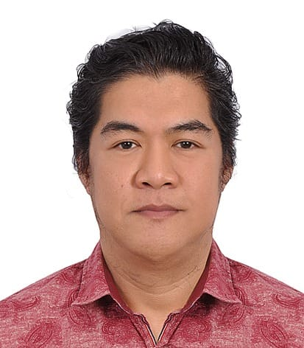 Luwemar V. Boniel  Profile: Motivated individual enthusiastic about challenging work. Adapts easily to different environments and flexes with changing demands.  Employment History  Housekeeping, archive clerk- Telal Real Estate, Al Fujairah, UAE  Augusnce,t 2017 — Present (READY FOR CANCELLATION)  - Handled Villa & apartment for Multi task working such as maintenance fixing items, receiving Guest payments, etc.  - Maintain and managing cleanliness of Villa & Apartment inside & outside.  - Dusting shelves, vacuuming floors, washing walls and windows, scrubbing floors, or sweeping and mopping floors.  - Proper beddings.  - Cleaning bathrooms, stocked with fresh linens and supplies such as toilet paper and shampoo, soap.  - Cleaning kitchen surfaces, counters and cabinets, emptying trash cans, and washing dishes, collecting garbage.  Sales Marketing, Wadi Al Hello drinking water, Sharjah, UAE  March 2016 — June 2017  - Drinking water deliveries  - Collecting payments by Cash and Debit card purchased  - Dealing negotiation for new customer  Sales Associate, G-tech Advance System, Al Fujairah, UAE  August 2014 — March 2016  - Selling laptop, printer, cables and router  - Receiving outside call order  - Inventory and tagging price new arrival items  - Collect cash and debit card payments.  Sales Associate, Samir Optical, Ras al-Khaimah, UAE  May 2012 — May 2014  - Selling branded sun glass and contact lens  - Handled cash registered machine and debit card transactions  - Replenishment and Inventory.  Sales Associate, Lal's Novelty Group of Company, Ras al-Khaimah, UAE  February 2009 — February 2012  - Selling coat, shirts, pants, belt, socks for men's and ladies  - Collect cash, cheques, debit card payments,  - Inventory and Price tagging of items  - Merchandizing  Room Attendant, Shangri- la Hotel, Makati City, PHILIPPINES  November 2002 — August 2004  - Changed bed cover, replenishment of new linen  - Bathroom cleaning, vacuuming, mopping and sweeping  - Mirror cleaning and dusting.  - Lost and found items,  - Dumping garbage, and other useless material.  Production Worker, Gold Circuit Electronics. Ltd. Chung li, TAIWAN  May 1999 — June 2001  - Loading and unloading chemical containers from palette.  - Machine or Conveyor operation/ Panel or PCB board loader/ Coating/ Copper ball loader/ Chemical temperature/ Conveyor blower, PCB brushing/ Chemical mixing  - PCB Packaging.  Factory Worker, Shin- Yi Fiber Ltd. Tainan TAIWAN  August 1995 — September 1998  - Loading / unloading products  - Collect and separate the cage by colors of bobbin threads from conveyor machine. / counting by pieces.  - Manual packaging of bobbin of threads  Stock clerk, SM Mercantile Stores Group, Manila, PHILIPPINES  July 1991 — July 1995  - Handling stocks from Warehouse.  - Delivery, packing, and movement of items and goods. Fulfill multiple tasks, including receiving, storing, transferring, and merchandising stock, Inventory, tagging price new arrival items.  - Replenishment of items in selling area and cubicles,  Education:  Computer Programmer, Interface Computer College, Manila, PHILIPPINES  JANUARY 2002 — MAY 2002  Microsoft Windows, Word, Excel, Access  Radio Operator, National Radio School and Institute of Technology, Manila, PHILIPPINES  MAY 1986 — MARCH 1988  General Radio Communication Operator. | Details:  Mina Al Fajer, Dibba Al Fujairah, 13260, United Arab Emirates  +971 554371322/+971 567049447  bluwemar@gmail.com  Nationality  Philippines  UAE Driving license  Light Car vehicle  Place of birth  Manila  Skills:  Ability to Work in a Team  Flexibility and Reliability  Strength and Stamina  Dependability and Initiative  Dexterity and Hand eye  Excellent oral communication  Mental agility and efficient.  Work Additional Info:  Handling heavy loads  Crouching, bending, kneeling  Standing for extended periods  Walking, pulling  Repetitive task  Technical Training:  Basic Fire Fighting, UAE Civil Defence 23, Jan. 2023  Philippine Nautical Institute, 2003  Basic Safety Training, Apr.-May’  - Personal Survival Technique  - Fire Prevention and Fire Fighting  - Elementary First Aid  - Personal Safety and Social Responsibility.  LANGUAGE:  Philippines, Tagalog Native language  English, Upper intermediate, B2  Chinese, Mandarin Elementary A2  Japanese, Nihongo Elementary A2  Arabic, Elementary A2


