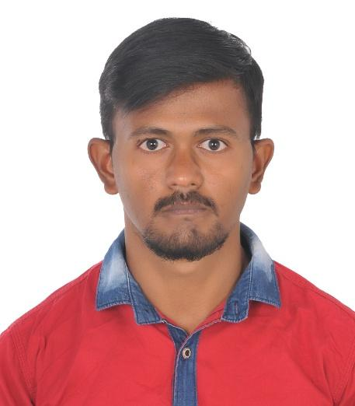

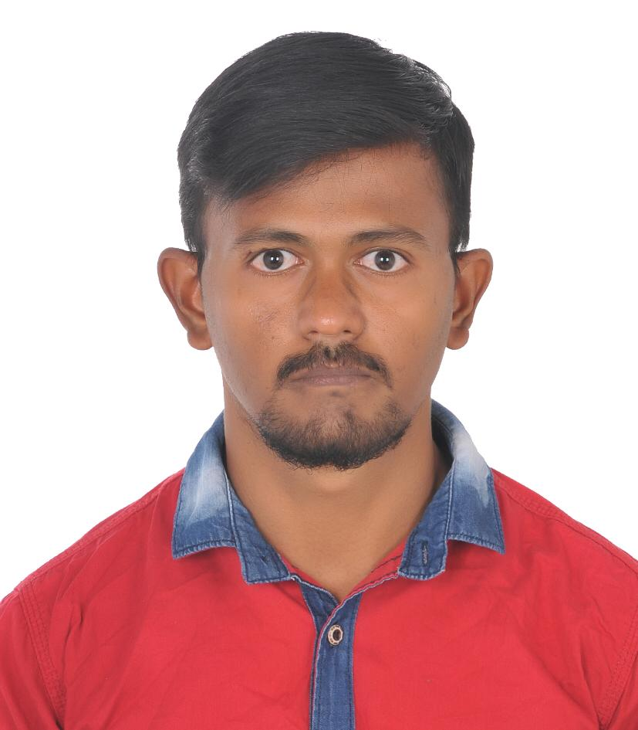

Contact details

Address

74,Kamarajar Street,

New Meenakshi Nagar,

MADURAI – 625009

Email-Mduveera93@gmail.com

+919087445517

OBJECTIVE

**MADURAIVEERAN DHAMOTHARAN**

**OBJECTIVE**

Secure a responsible career Opportunity to fully utilize my training

And skills, while making a significant contribution to the

Success of the company.

.

ACADEMIC QUALIFICATION

SKILLS

* **Communication and high self-confident level.**
* **Problem solving and customer service.**
* **Leadership quality.**
* **Be punctual**
* **AREA OF INTEREST**
* **Eager to known technology oriented updates.**
* **Playing games**
* **Listening songs**
* **Reading stories etc;**

**LANGUAGE KNOWN**

**TAMIL**

**ENGLISH**

**HINDI**

**KANADAM**

**MALAYAM**

X Standard passed out from SOURASTRA BOY’S HIGH SCHOOL, Stateboard,Tamilnadu.Madurai

.

WORK EXPERIENCE

**Toyoda Gosei South India Pvt Ltd, Bidadi Bangalore**

**2015-2020**

I had experienced in Multi -Tasks Oriented Housekeeping Supervisor

Paint sludge handling, Kaizen Products Support, Chemical hazardous

Handling, cleaning Activity, Document alignment controller.

**UAE EXPERIENCE :**

**VAIGAI EXPRESS RESTRAUANT**

**2020-2022**

CASHIER ROLES & RESPONSIBITIES

* Processed customer payments.
* Stocked supplies and paper goods as needed.
* Performed other job functions assigned.
* Greeted customers and ensure the best guest experience
* Guided through ordering process.
* Basic computer and technical skills
* Customer service abilities

T.CHOITHRAM & SONS

June 2022 – jan 2024

* + Stock filling
  + Arrange the gandolas
  + Check the expiry
  + Shift management
  + Handling F&V section
  + SAP workout