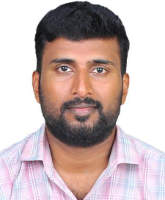

**Mathews A. Koshy**

Email: mkoshy101@gmail.com

Mob: +916235533828

**Career Objective**

Seeking a position to utilize my skills and abilities in the industry that offers professional growth while being resourceful and flexible for the development of the company.

**Personal Skills**

1. Good Communication Skills
2. Believe in continuous learning
3. Strong Analytical problem Resolving Skills
4. Dedication and Adaptability

**Technical Skills**

Proficient in Microsoft Technologies, Networking Operating System and Lan Supports

**Educational Qualification**

**Degree in Bachelor of Arts**

**Diploma in Logistic & Supply Chain Management**

**Microsoft Certified Professional** – MCP (MCP ID #6425822)

**Microsoft Certified System Administrator** – MCSA Messaging

**Job Experience**

Worked as a **Network Support Engineer** since July 2009 to July 2010 at **BPCL Cochin Refinery Kerala, India.**

**1.**

Worked as a **Billing Officer (Insurance Company)** since 02 July 2011 to 09 July 2022 at **Al Hammadi Hospital, Riyadh, Saudi Arabia**.

1. Prepare the insurance company invoices for inpatient and outpatient.
2. Coordinating with insurance company for various medical services.
3. Medical Insurance approval taken from insurance company for both inpatient and outpatient customers.
4. Code and agreement creation for the insurance company for the customers.

**Strengths**

* Optimistic and confident outlook towards life.

### Excellent interpersonal and communication skills.

### High sense of commitment & Responsibility.

* Ability to identify growth, learn new things and constantly upgrade my skills.
* Ability to manage people diplomatically and tactfully.

**Personal Profile**

Name : Mathews A. Koshy

Date of Birth : 21/02/1988

Marital Status : Married

Sex : Male

Languages Known : English, Malayalam, Arabic, and Hindi.

Nationality : Indian

**Reference**

Available upon request

**Declaration**

I hereby declare that all the above information is true and correct to the best of my knowledge and belief.

**Mathews A. Koshy**