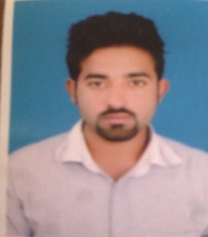**MEHRAN UL HASSAN**

House No. 292, Model Town B,

Bahawalpur

Cell #: +92-309-7888869

## dabbi**OBJECTIVE**

To pursue a challenging career in a dynamic and progressive organization, with the aim of utilizing my knowledge and creativity furtherance of my own and the organization’s objectives.

## dabbi**PERSONAL INFORMATION**

* Father’s Name : Badar Ul Hassan
* Date of Birth : 10-12-1992
* CNIC : 31202-7360580-1
* Marital Status : Single
* Domicile : Punjab
* Nationality : Pakistani
* Religion : Islam

dabbi**PROFESSIONAL QUALIFICATION**

|  |  |  |
| --- | --- | --- |
| **DEGREE** | **YEAR** | **BOARD/UNIVERSITY** |
| Mphill (Computer Science) | 2021 | NCBA&E |
| M.Cs | 2016 | NCBA&E |
| B.Sc (Double Comp stat) | 2014 | Islamia University Bahawalpur |
| I.Cs | 2010 | BISE |
| Matric | 2008 | BISE |

dabbi**EPERIENCE:**

* 1 year IT Head in Baber Medicine Company.
* 2 Years Computer Networking In DTD Gaming Zoon Bahawalpur Trade Center.
* 7 year Assistant Controler Examination in Punjab College Main Campus Bahawalpur.

**SKILLS & ACHIEVEMENTS:**



* Self-Motivated and hardworking.
* Effective and result oriented leadership skills.
* Can work under time pressure.
* People friendly and good listener.
* Good communication / Drafting skills.

**dabbiREFERENCE**

* Will be provided on demanded.