A challenging position in a progressive organization that will utilize my talents and provides me with an opportunity for personal and professional growth

# CONTACT

**+971 547738744** midhunkalayil.89@gmail.com

Passport : P2698549

DOB : 29/04/1990

# LANGUAGE

Malayalam

Hindi

English

Tamil

Kerala Higher Secondary

Examination Board

## 2005 - 2006 TECHNICAL SKILLS

D.F.A (MS Office, Data

Entry, Tally)

## EXPERIENCE

08 Months-More

Supermarket

6 Months -GODREJ -

Accounts assistant

3 year-Techmac IT

Innovators Ltd a-Customer

Service Executive in EDC

Machine services 09 months & 6 months-Lion dates and Nirapara as marketing executive 6 years - Aluminum fabricator

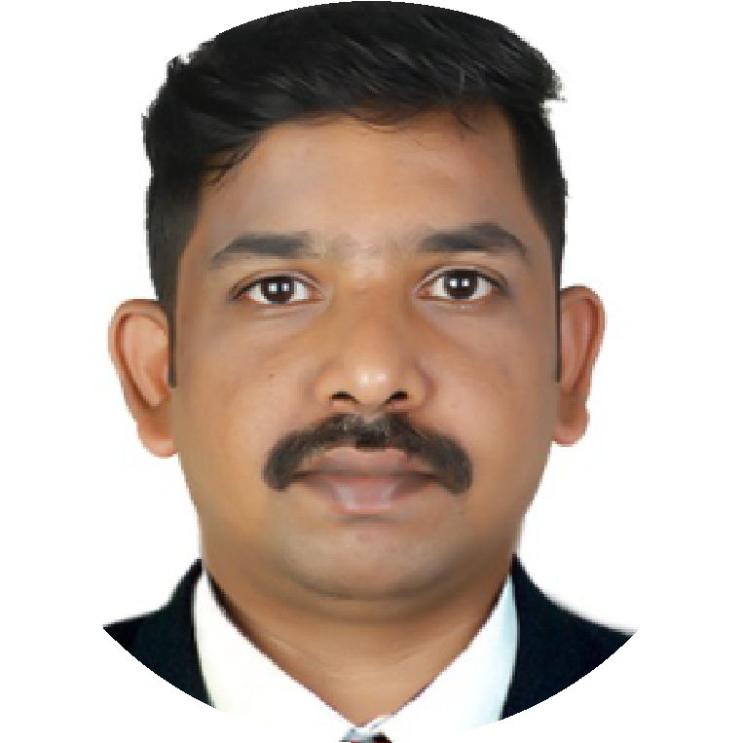

MIDHUN KALAYIL

PROFILE

EDUCATION

Last 6 months worked as a cashier at White

House Restaurant -Dubai