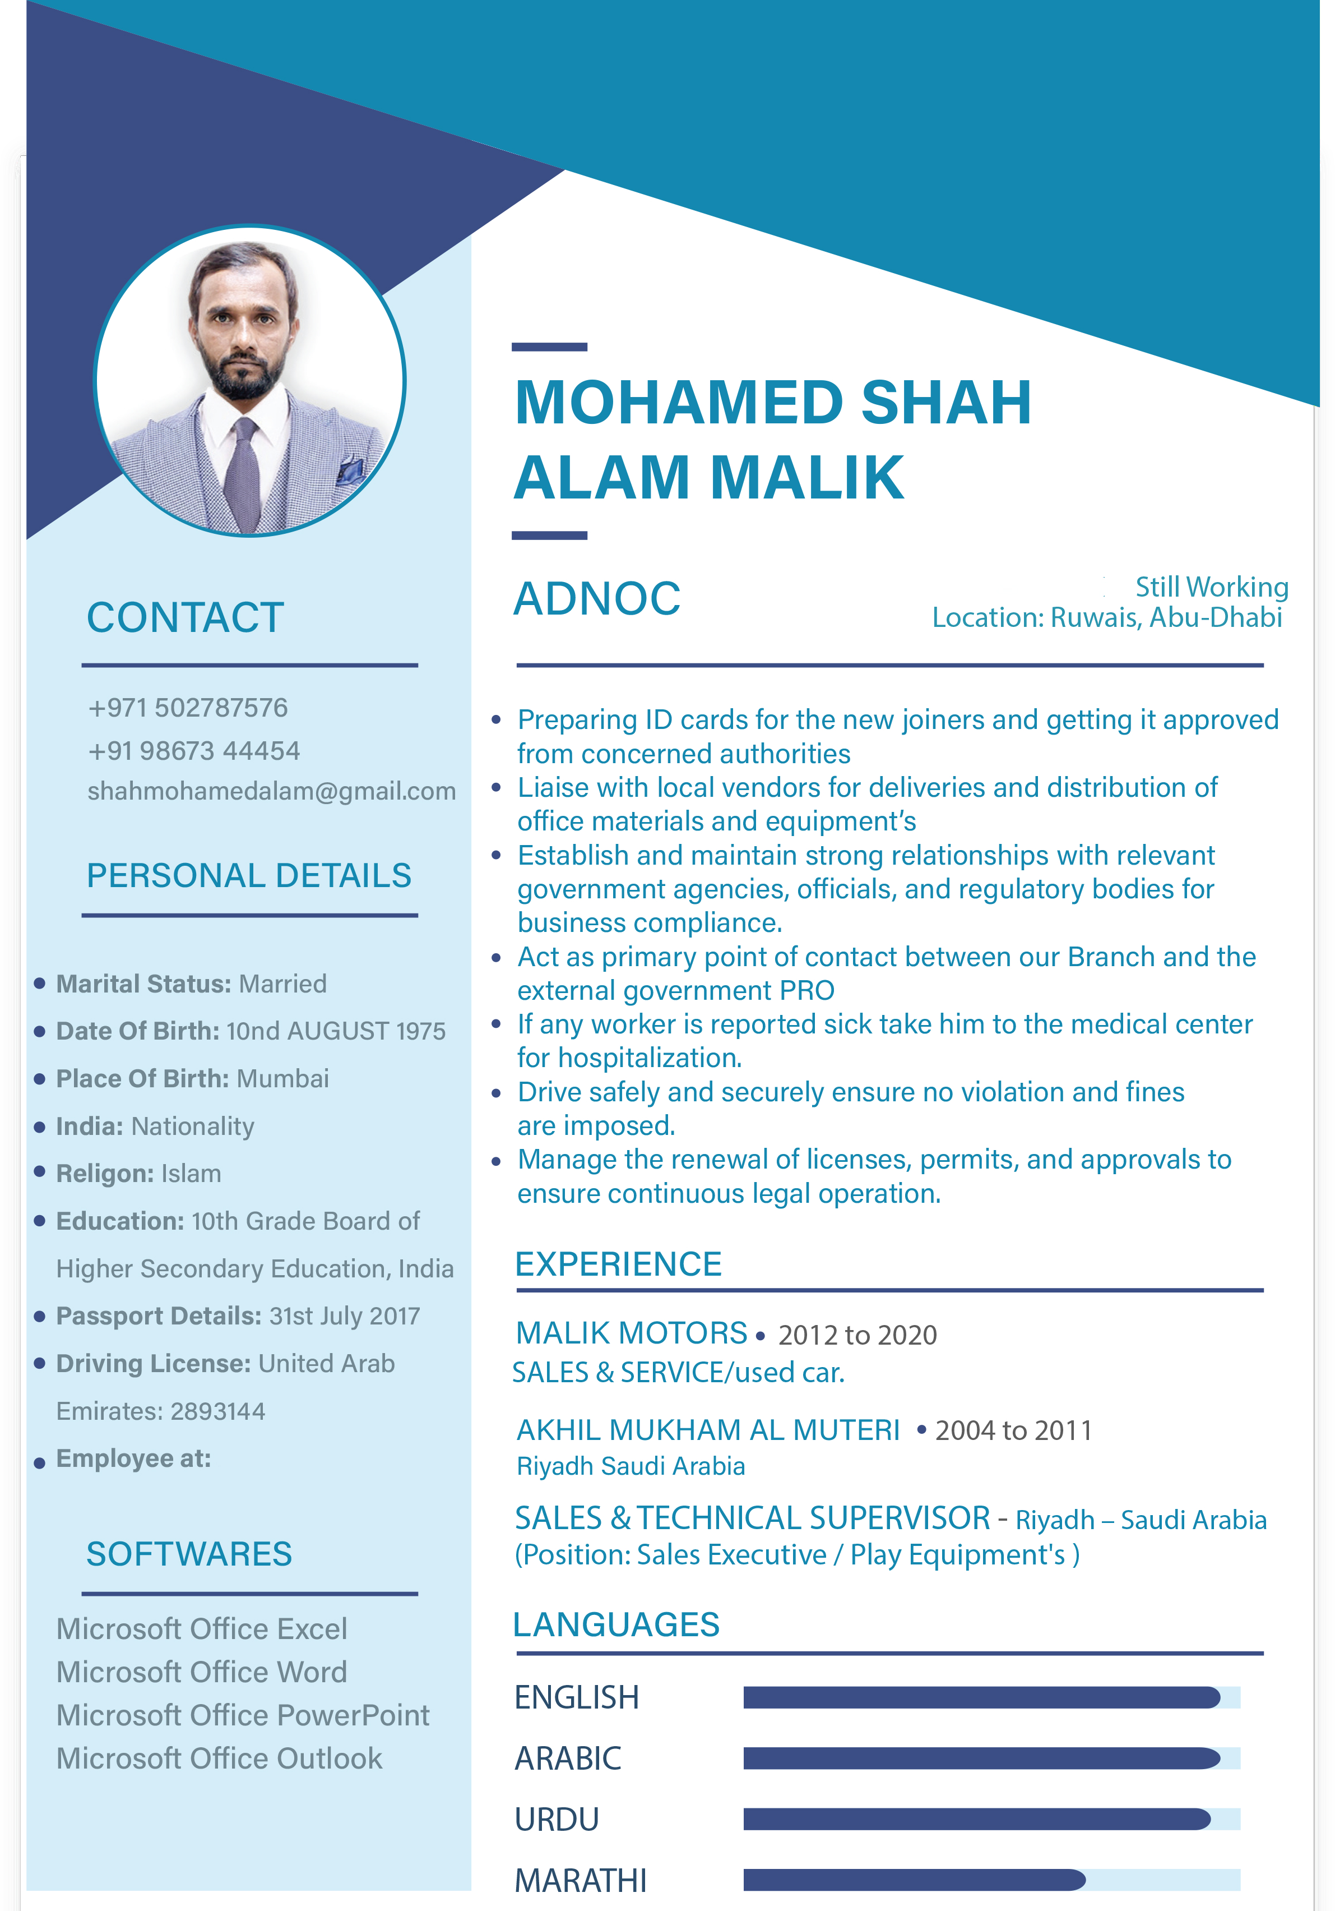

**REFINERY**

**COORDINATOR**

050 1894738

( MANUAL )

ADVANCED PETRO SERVICES.