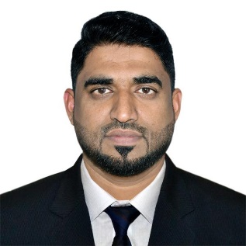

**Mohammad Irshad**

Sales & Operations Manager / Key Account Manager (FMCG) / Sales Supervisor  
Mobile: +97150-7094489

E-mail: [m.irshad6071@gmail.com](mailto:m.irshad6071@gmail.com)

**Professional Summary**

Goal-driven professional with 19+ years of expertise in **Sales & Distribution**, **Operations**, **Marketing**, and **General Administration**. Skilled in **Business Strategy**, **Brand Promotion**, **Market Research**, and **New Product Launches**. Strong leadership in managing teams, supervising operations, and training & development. Known for outstanding communication, analytical, and critical thinking skills. Adept at decision-making, time management, and high-level correspondence.

**Career Progression**

**Sales & Operations Manager (Retail & Van Sales)**  
*Golden Classic Foods* | *4 Years (2021-Present)*

**Sales Supervisor (Modern Trade)**  
*Lebanese Fruit Co. (LIFCO)* | *3 Years (2018-2021)*

**Assistant Key Account Manager (Lulu & Carrefour)**  
*Lebanese Fruit Co. (LIFCO)* | *4 Years (2014-2018)*

**Sales Representative (Key Account Outlets)**  
*Lebanese Fruit Co. (LIFCO)* | *5 Years (2009-2014)*

**Sales Merchandising**  
*Lebanese Fruit Co. (LIFCO)* | *4 Years (2005-2009)*

**IT Skills**

* Well-versed in **EMAS, LFS** and **OUTREACH** graphics applications.
* Proficient in **MS Office Suite**, **Email Applications, Corel**, **Photoshop**.

**Training**

Conducted by **Dr. Sunil Gupta** (IDEAS Management Consultants):

* Merchandising Skills (2007 & 2009)
* Basic Selling Skills (2012)
* Advanced Selling Skills (2012)
* Management Skills (2014)

**Areas of Expertise**

* Sales & Marketing

**Strengths**

* Managing sales team
* Sales Analyst (YTD & MTD)
* Rebate Negotiator
* Communication
* Teamwork
* Organization & Coordination skills
* Hard work & Dedication
* Problem Solving
* Business Development
* Brand Management
* Retail Operations
* Distribution Management
* Channel/Retail Management
* Client Management
* Strategy Planning
* Product Launch & Promotion
* Budgeting
* Profit Centre Operations
* ROI Accountability

**Education**

**Bachelor Programme of Business Management**  
*Institute of Basic and Vocational Education*

*Mangalore, India***Personal Details**

**Nationality**: Indian  
**Date of Birth**: 22nd June 1986  
**Marital Status**: Married  
**Visa Status**: Employment  
**Languages**: English, Hindi, Malayalam, Kannada, Tamil, Basic Arabic  
**References**: Available upon request

**Driving License**

Valid UAE Driving License: License No. 454279 SHJ (Issued: 2009)