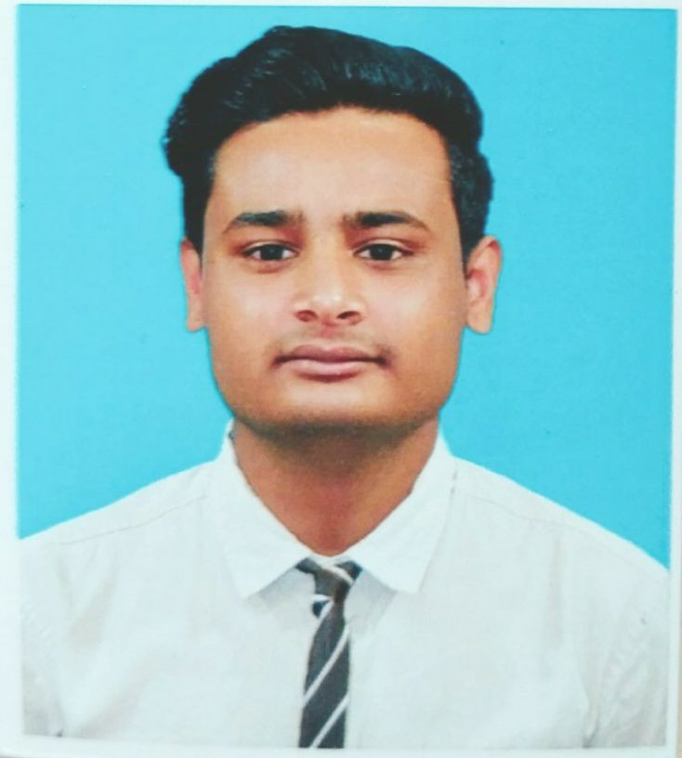
MOIN AKHTAR RAZVIE

+971 581285637

meena baazar, Burdubai, Dubai (UAE)

moinakhtar4840@gmail.com
 EXPERIENCE
AVENUE SUPERMARCKET ( D- MART)
CASHIER

VISHAL MEGA MARCKET
SALES ASSOCIATES

08 FEB -2021 - 23
FEB - 2022
14 MARCH 2020
15 AUGUST 2020

 OBJECTIVE

YOUR FITNES CENTRE
FRONT DESK Associates
23 JULY 2022
1 JANUARY 2023


Obtain a challenging leadership position
applying creative problem solving and lean | EDUCATION
management skills with a growing company
to achieve optimum utilization of its resources and maximum pro ts. | B. COM COMPUTER APPLICATION WITH FIRST DIVISION FROM  VIKRAM UNIVERSITY UJJAIN | 2020
 | HIGHER SECONDARY WITH FIRST DIVISION FROM M. P. BOARD | 2017


SKILLS
TIME MANAGEMENT CUSTOMER SERVICE PROBLEM SOLVING EMERGENCY RESPONSE FLEXIBILITY
TEAM LEADERSHIP

 INTERESTS
TRAVELLING SINGING
BHOPAL

HIGH SCHOOL WITH SECOND DIVISION FROM M. P. BOARD BHOPAL

 ACHIEVEMENTS & AWARDS
Two time achieve star of the month Sales certification

 PERSONAL SUMMARY

2015

READING BOOKS MEET NEW PEOPLE

 LANGUAGE
HINDI ENGLISH
I am a person who is highly motivated and enthusiastic to attain goals and hardworking able to work with minimum supervision and I am also highly exible and adoptable to changing environment.

PERSONAL DETAILS
DATE OF BIRTH - 25-08-1999 NATIONALITY. - INDIAN WEIGHT. - 63 KG
HEIGHT. - 168 CM
MARITAL STATUS - UNMARRIED

COMPUTER AND OTHER SKILLS
M. S. OFFICE
M. S. EXCEL INTERNET POWER POINT TALLY ERP 9

