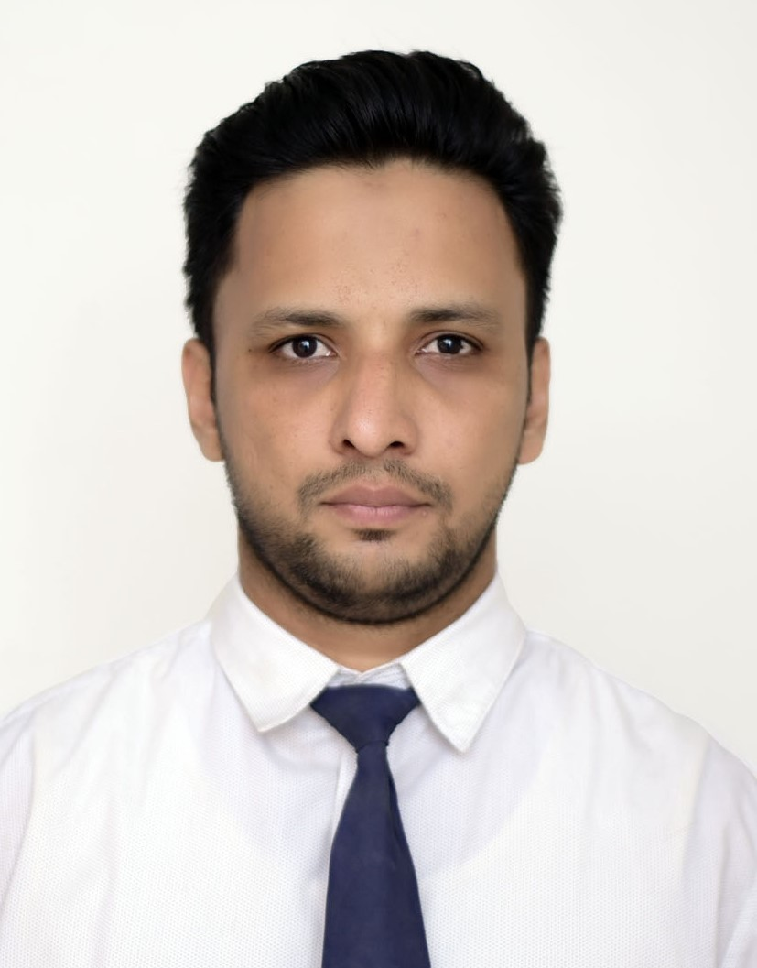

Muhammad Jibran Khan.
Present Add: Plot # R-538-539, Jacob Line, Saddar, Karachi.
Phone: 03323141268
E-mail: Jibran86@yahoo.com

Objective:

To lead the organization being strategic partner of top management team of organization.

Professional Profile:

To be a part of a reputed and progressive organization in order to gain knowledge and assist the professionals in performance of their duties & responsibilities for achieving their goals and objectives efficiently & effectively.

Professional Experience:

- Zhicheng Pakistan Pvt. Limited. (From April 2017 to Present)
Working as “Senior Accounts Officer".
Job description:
• Bank Reconciliation.
• Monitoring invoicing, payment and recovery.
• Preparation of Financial Statements i.e. from General Entry to Ledgers, Trial Balance, Profit &
loss account and Balance Sheet.
• Preparation of monthly statements as per the company requirements.
• Preparation of supplier’s accounts (purchase order, purchase bills).
• Prepare and maintain daily account payable & account receivable records.
• Perform Cashier duties including receipts and payments at front desk
• Prepare and process import documentation according to customs regulations, laws, or procedures.
• Prepare Tax Payment.
• Opening of LCs and liaison with banks
• To deal with EOBI & SESSI related all activities.

- Surround Architect / Build Out, Karachi. (From April 2015 to March2017)
Worked as “Store Incharge /Site Accounts", at project of Bahria Town Icon Tower, Karachi.
Job description:
• Receive, distribute and maintain adequate quantities of stocks at all times.
• Maintain optimal stock levels and consumption record.
• Inform the purchase department well in advance about the items that reach the re- order
Level to order from supplies.
• Review physical inventories periodically.
• Keeps and updates records of good received and issued.
• Compiles report of expenditure, and monthly stock report.
• Maintain daily cash expenses, accounts, salary & wages sheets.

- Creative Construction. Company / Pyramid Housing Services (From March 2012 to March 2015)
Worked as “Accountant".
Job description:
• Organize and maintain financial records.
• Maintain daily cash inflow & out flow & Bank Transaction.
• Bank Reconciliation.
• Maintain salary & wages sheets.
• Monthly closing accounts.

- IK Associates, Karachi. (From Aug 2010 to March 2012)
Worked as “Assistant Manager Finance”.
Job description:
• Preparing & maintaining Invoices, Quotation, and Tender.
• Maintain daily cash expenses & Bank transaction.
• Maintain salary & wages sheets.
• Organize and maintain financial records.

- Trans-Asia Trading (Pvt.) Ltd. Karachi. (From Dec 2009 to May 2010)
Worked as “Account Executive”.
Job description:
• Preparing & maintaining Invoices, Quotation.
• Maintain daily cash expenses & Bank transaction.
• Organize and maintain financial records.
• Reporting to Financial Head.

Internship:
- Pakistan Beverage Limited, (Pepsi).
• 6 weeks internship in Finance & HR Department.
(From June 2010 to July 2010)

Computer & Accounting Software Skills:
- Institute of Business & Professional Development (IBPD)
(Feb 2018 to Aug 2018)

- SAP (End User)
- Tax Filling FBR
- Quick Book.
- Tally Accounting
- Advance MS-Office Expertise.

Academic & Professional Qualification:

Degree / Certificate | Institution / University | Years
MBA (Finance) | Mohammad Ali Jinnah University, Karachi. | 2011
BBA (Hons) | Mohammad Ali Jinnah University, Karachi. | 2009
B-Com (Commerce) | University of Sindh, Jhamshoro. | 2006
HSC (Pre-Engineering) | Government College, Hyderabad. | 2004
SSC (Science) | Saifiya High School, Saddar, Hyderabad. | 2002

Personal Information:

- Father’s Name: Zahid Ahmed Khan
- Surname: Lodhi, Pathan
- Date of Birth: 24th January, 1986
- Marital Status: Married
- C.N.I.C No: 41304-4950564-9
- Passport No: AC1569491
- Religion: Islam
- Nationality: Pakistani

Language:

- English, Urdu.

Hobbies & Other Activities:

- Interested in Cricket, new experience.

Reference:

- To be furnished upon my request.

