**PERSONAL PROFILE**

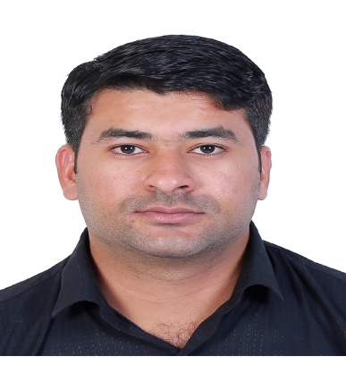

**MUHAMMAD MURSALEEN**

**Gender: Male**

**Nationality: Pakistan**

**Date of Birth: 01-03-1997**

**Marital Status: Married**

**Phone: 03363696558&03102043633**

**Wasp: +971 564667785**

**Email:mohammadmursalin194@gmail.com**

**EDUCATION**

**Bachelor in Commerce**

**LANGUAGES KNOWN**

**English, Urdu**

**CAREER OBJECTIVES**

To be associated with a well-established company that will provide good opportunities for my growth and career advancement. To handle challenging jobs that will enhance my analytical ability and decision making.

**SKILLS AND ABLITIES**

* Good Communication Skills
* Attention to detail
* Communication
* Product knowledge
* Time management
* Interpersonal communication
* Computer literacy
* Problem solving
* Teamwork
* Conflict resolution
* Multitasking.

**EXPERIENCE**

* 2-Year Working Experience as a Assistant Manager in Baby Shop Karachi - Pakistan
* 3 Years Experience as a crew in McDonald’s UAE
* 2 Years Experince as a cashiar in sappphire Karachi Pakistan
* 3 years experience as a receptionist in national medical center (NMC)karachi

**DUTY & RESPONSIBILITIES**

**Assistant Manager Responsibilities**

* Assisting the general manager in organizing, planning and implementing strategy.
* Coordinating day-to-day operations.
* Ensuring that company guidelines are followed.
* Setting up and organizing schedules.
* Devising and setting up objectives to boost company productivity

**Mc Donald Crew Responsibility**

* Manage food preparation, maintain cleanliness and punctuality while effectively support customers in daily transactions with suggestive *selling* methods.
* Utilize customer service skills while displaying creativity with culinary art to ensure a positive atmosphere for all guests and co-workers.
* Provide genuine customer service to all guests, daily use of computerize POS terminal, adhere to training guidelines of company.
* Communicate clearly and positively with coworkers and management, master point-of-service (POS) computer system for automate order taking.
* Maintain waste and HACCP logs.

**DECLARATION**

I, hereby declare that all above information is true to the best of my knowledge and belief

**MUHAMMAD MURSALEEN**