

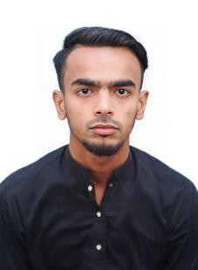MUHAMMAD SAMEER

Mobile : 055-2710997

Email [:muhammadsameer1852@gmail.com](mailto:muhammadsameer1852@gmail.com) Location : Sharjah – U.A.E.

**Objectives:** Eager to work with a professional organization, which all recognize, appreciate and fully utilize current skills and knowledge base, which providing opportunities and career advancement.

# Education Detail:

# Intermediate: Commerce

S.M.GOVT.ART & COMMERCE COLLEGE NO.1, Karachi & Pakistan.

(Februady 2018 - February 2020)

**Marticulation**: Commerce

Al Makhdoom Public School, Karachi & Pakistan.

(March 2015 - March 2017)

# Skills Profiles:

* Good communication and interpersonal skill.
* Hard working team member.
* Have the ability to work for long hours.

# Work History :

* 02 Year Service in One Window Mall as a Salesman.
* 03 Year Service in Grip Led Lighting as a Salesman at Wholesale Bolten Market.
* 02 Year Service in Pervez Pharma as a Salesman at Wholesale Medicine Market.

# Personal Profiles:

Father’s Name : ABDUL KARIM

Nationality : PAKISTAN

Date of Birth : 03/10/1999

Sex : Male

Marital Status : Un-Married

Language Known : English, Urdu, Sindhi

# Certifications:

* Microsoft office.
* Window installation.