**CURRICULUM VITAE**

**Mr. MUKESH KUMAR** 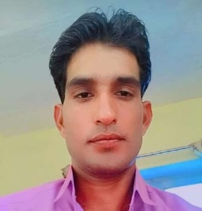

S/O ISHWAR LAL RANWA VPO-BHEERANA

THE-DANTARAMGARH Dist. SIKAR Rajasthan(IND)

Mob.No. -971503540325

Email id; mukeshkumar351336@gmail.com

**CAREER OBJECTIVE**

To be associated with an esteemed organization that can fulfill my job requirements and provide me a way for successful career in the future and to build a carrier by joining in a progressive organization prepared to take up any challenging position by continually improving on knowledge and skills.

**EDUCATIONAL QUALIFICATIONS**

* **10th**from **Rajasthan Board Of Secondary Education, Ajmer** in **2011**
* **12th**from **Rajasthan Board Of Senior Secondary Education, Ajmer** in **2013**
* **ITI From NCVT, sikar in 2015**
* **RS -CIT COMPUTER Course**
* **Security guard Course**
* **EXPERINCE**
* **EXPERIENCE : SUPERVISOR**
* **PLACE:-DAYMAND MILL SURAT (GUJARAT)**
* **2 YEARS EXPERINCE**
* **EXPERINCE : STOREKEEPER**
* **PLACE: SHREE SAI COACH (GUJARAT)**
* **2 YEARS EXPERINCE**
* **PERSONAL DATA**

**Name : MUKESH KUMAR**

**F’ Name :ISHWAR LAL RANWA**

**D.O.B : 20 Aug 1995**

**Sex : Male**

**Marital Status :Married**

**Language Proficiency : Hindi & English**

**Nationality : Indian**

**PASSPORT NO : P4671594**

**CONTACT DETAILS**

**Permanent Address VPO-BHEERANA THE-DANTARAMGARH**

**Dist. SIKAR Rajasthan, 332025**

**Mobile No. : 971503540325**

**Email Address mukeshkumar351336@gmail.com**

**DECLARATION**

**I declare that the above information is authentic to the best of my knowledge and if found any discriminancy then I is solely responsible for that.**

**Name : MUKESH KUMAR**