**SHADRAQ O. MUSADDIN**

**Contact Number:** 056 758 4139

**WhatsApp:** 058 180 6479

**Email:** shaddygreat123@gmail.com

**Address:** Al Dustoor St., Villa 9, Jumeirah 3

**CAREER OBJECTIVE:**

Looking for an entry-level career in any position that is relevant to my degree program, personal experience and skills to enhance and expand my learning and practical knowledge in the field of my program. Aiming to land in a progressive and growing organization that would help me with my goal and to have experience working in a real, reputable, and high-level professional setting.

**EDUCATION:**

|  |  |
| --- | --- |
| **Bachelor of Arts in International Studies Major in European Studies** |  |

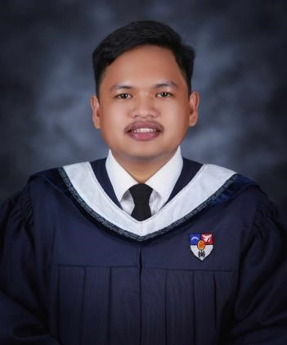

Xavier University - Ateneo de Cagayan

Corrales St., Cagayan de Oro City, Misamis Oriental, Philippines

**RELEVANT COURSEWORK: TECHNICAL SKILLS:**

* Technical Writing Data Entry and Management - Microsoft Office
* Academic Writing Excellent Communication - Oral and Written
* Research Aide/Assistant Minor Troubleshooting - Hardware and Software Issues
* Public Relations Efficiency in Microsoft Office Softwares
* Communication

**CAREER SUMMARY:**

**Freelancing - Academic Writing** (July 2021 - August 2022)

* **Academic Term Paper - "Effects of a Poor Healthcare System towards Filipino Citizens" (**July 2021)
* Composition of a 10-page Academic Term Paper for a client; which includes topic selection, title generation, draft making and finalization of the project.
* **Data Input/Entry and Analysis - Academic Level Culinary Feasibility Study** (August 2022)
* Tasked to work on the data input and research part of a Feasibility Study. Data includes prices, steps and processes of each set menu, set menu costing and it's data interpretation (popularity, profitability, and effectiveness).

**Logistics Member - Xavier University - Ateneo Diplomatic Corps' Historical and Diplomatic Tour**

(April 2023 - May 2023)

* Networking and Information – Securing travel and food itinerary, hotel booking
* Troubleshooting – PC reformat, Motherboard restoration, Power Supply troubleshoot, & Keyboard/Mouse troubleshoot
* Administrative – Organizing seminars and program preparation

**Food Handling and Services – Te Abs Grill and Resto** (September 2023 - July 2024)

* Food Preparation and Packing
* Cleaning and Disinfecting Utensils
* Food/Buffet Serving
* Food Stall Management - Food and Beverage