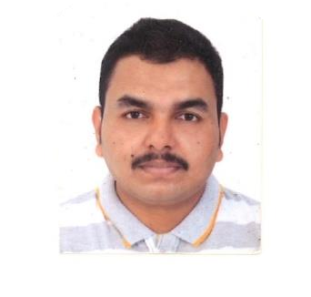
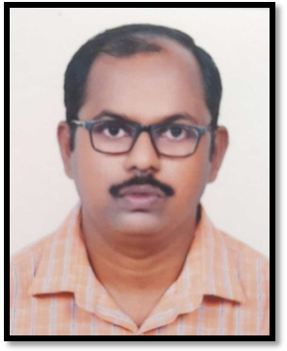
RAJESH.S
SALES MANAGER

Contact Information
Address:
RollaStreet,Burdubai,
UAE
Email: rajeshsubramaniapillai82
@gmail.com Mobile: +971-565680052

Personal Details:
Date of birth:10/05/1982 Nationality : Indian Sex : Male
Marital Status : Married

Passport Details:

Passport No : V3049884 Date of Issue: 12/10/2021
Date of expiry:11/10/2031

Languages Known
- Malayalam
- English
- Τamil
- Hindi
Skills
- Communication skills
- Customer Service
- Coordination and Management
Technical Skills
- Knowledge in Windows 2007,2010
- MSOffice
- Net Browsing
- Typing

Profile
Seeking an innovative and challenging position in the organization which
experienced and results oriented Sales Manager with Fifteen years of
managerial experience in retail environments. Motivated professional with
Strengths in supervising employees and promoting optimal customer service.
Employment History
Sales Manager, Prabhus Books, Trivandrum
January 2009-November 2023
- Developed a sales forecasting model that accurately predicted future sales trends
- Conducted weekly sales meetings to provide guidance and review progress resulting an improvement in team morale
- Developed a successful sales strategy that resulted in a 100% increase in sales

Cashier, Prabhus Books, Trivandrum
January 2003-December 2008
- Stocked shelves and ensured product displays were organized and attractive
- Handled customer complaints calmly and professionally resolving customer issues in a timely manner
- Maintained an accurate cash drawer, reconciling discrepancies etc.
- Processed payments quickly and accurately resulting an increase in customer satisfaction

Salesman, Prabhus Books, Trivandrum
May 1999-December 2002
- Conducted in depth customer needs assessments to create tailored solutions that met their needs
- Delivered high impact presentations to potential customers that resulted in increased sales
- Developed innovative marketing strategies that increased customers

Education
BCOM Kerala University
July 2004
Pre Degree Kerala University
June 1999
SSLC Fort High School
June 1997
Declaration
I hereby declare that above information is true in my knowledge and belief

