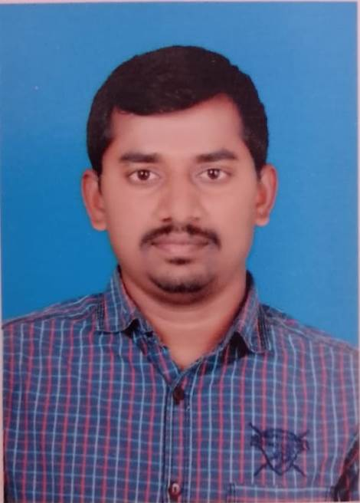**CHENGAL RAYUDU MAVILLA – RESUME**

**Personal Information**

Father’s Name : M Pedda Chengaiah

Date of Birth : 16-05-1985

Sex : Male

Nationality : Indian

Marital Status : Married

Phone number : 8143139360

E Mail : [rayudu705@gmail.com](mailto:rayudu705@gmail.com)

Passport No : Y8224959

**“To** emerge as a hard core Professional and prove myself as an important part of the organization by the achievement of given target and to work in challenging project that will utilize my educational background and expand my knowledge.”

Professional Summary: I have a total Experience of 16year

**Organization :** K.C.V.R INFA PROJECTS PRIVATE LIMITED

**Duration :** June-2020 to Aug-2023

**Designation :** Supervisor

**Organization :** **KGL Logistics – Kuwait (ASI Security)**

**Duration :** July-2015 to March-2020

**Designation :** Cash Management Service

**Organization :** Plus Ventilation Private Limited

**Duration :** March-2011 to April-2015

**Designation :** Accountant

**Organization :** Nava Bharath Fertilizers Limited

**Duration :** Dec-2007 to Feb-2011

**Designation :** Internal Auditor & Executive Accountant

Roles and Responsibilities Organization

**AREAS OF EXPERTISE**

* Updating Books of accounts on real time basis in ERP and maintenance of General ledgers.
* Accountable for the Maintenance of cash & bank books preparation of the age wise debtor statements and accounts receivable statements carrying out reconciliation of Vendor Ledger.

* Petty cash books
* Reconciliation Bank Statement and Stock Reconciliation with Actual consumption of Major Materials
* Inventory Status Report
* Payroll sheet including leave & final settlement for employees
* Verification and payments against the invoices submitted by suppliers in line with the Purchase orders.
* Actively participated in the finalization of financials like P&L, Balance sheet.
* Co-ordinate with external auditors and prepare reports and formats for their audit report purpose. Preparation of Weekly, Monthly reports to the management.
* Ensuring that the external audit requirements like Cross checking of document which tally with schedules are met
* CMS is a value-added product for Corporate Customers of the Bank who get money from multiple locations
* Oversee and maintain a safe, productive work environment for all on-site workers.

Major Strengths

* Self confidence
* Positive attitude and a self-Motivator
* Interest to learn new things

Software Skills

1. MS Office
2. Internet Browsing
3. Tally ERP 9 & Prime

|  |
| --- |
| Educational Profile |

|  |  |  |  |
| --- | --- | --- | --- |
| **Qualification** | **Institution/Board** | **Year of study** | **Class** |
| B.COM (Computers) | SV University Tirupathi, A.P | 2003-2005 | First Class |
| Intermediate (CEC) | Board of Intermediate, A.P | 2001-2002 | Second Class |
| SSC | Board of Secondary Education A.P | 1995-2000 | Second Class |

**Permanent Address**

M Chengal Rayudu

S/o. M Pedda Chennaiah

House No: 7/37, Narsarampet

Railway Koduru,

Annamayya District

Andhra Pradesh, India - 516101

**Languages known**

|  |  |  |  |
| --- | --- | --- | --- |
| **Languages** | **Read** | **Write** | **Speak** |
| English | Yes | Yes | Yes |
| Hindi | No | No | Yes |
| Arabic | No | No | Yes |
| Telugu | Yes | Yes | Yes |

**DECLARATION**

The Above Information Is True And Correct To The Best Of My Knowledge And Belief.

**PLACE: Dubai**

**DATE:**

**(M. CHANGAL RAYUDU)**