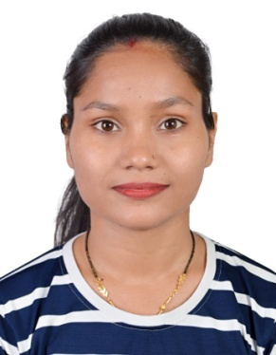

### **Declaration**

### I hereby declare that the above-furnished details are true and correct to the best of my knowledge and belief.

### MAMTA NIMBRAN

**Objectives**

To work in an environment conductive for innovative experiences, which offers me a Knowledge base, to enhance my talent, exposure and which in return benefits the organization.

**Work Experience**

* **Working as Cashier in Al Nahda Palace Gift, Dubai from June 2023 to till.**
* **Worked as Junior Relationship Officer in Axis Bank, Ambala City, Haryana – India from May 2021 to April 2023.**

**Skills**

* Easily Accept any Kind of Responsibility and Ability to Work Independently.
* Confident, Hardworking, Flexible and Optimistic.
* Good Knowledge of computer, MS Word, Excel etc.
* Communication Skills
* Good Organizational Skills.
* Sincere Approach in duties and
* Interpersonal skills
* Leadership quality
* Time Management
* Punctual focused and very dedicated to any task given.
* Good team spirit & hard working nature.
* Easily Accept any Kind of Responsibility
* Highly trustworthily, discreet and ethical.

**Personal Data**

###### Date of Birth : 15/08/1996

###### Gender : Female

Nationality : Indian

Marital Status : Married

**Passport Details**

###### Passport No : X9733476

###### Issue date :09/05/2023

Expiry date :08/05/2033

Visa Status : Residence Visa

**Languages Known:**

English, Hindi

**Education:**

SSLC (2012)

12th (2014)

B.A (2017)

M.A. (2020)

**MAMTA NIMBRAN**

**Contact: +971 555170658**

**mamtabedi6547@gmail.com**

**Al Nahda 2, Dubai - UAE**