Mario Llanos Cel ona Jr.

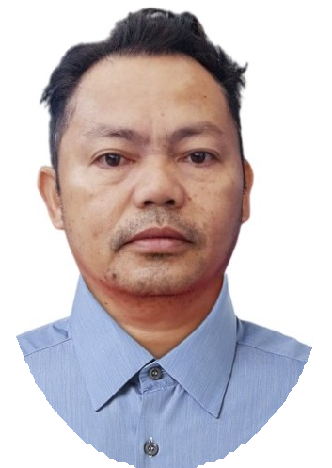

Contact Details

Phone:

+48608263991

Email:

[cellonamariojr3@gmail.com](mailto:cellonamariojr3@gmail.com)

Nationality:

Filipino

DOB:

16.09.1976

Gender:

Male

Address:

Ul. Duza Morawica Krakow, Poland.

Skills

Butchery

★ ★ ★ ★ ★

Language

English Arabic Tagalog Visayan



Summary

Passionate about securing a position where I can apply my skills and knowledge to drive inno- vation and achieve remarkable outcomes.



Education

Jun 1995 – Mar 1999



High School Diploma

Rizal Memorial College



Experience

Jul 2017 – Jul 2019



Alawshim Poultry Farm Marketing Ltd. Kingdom of Saudi



Arabia

Butcher

* Arrange Cuts of Meat and place them in attractive manner in the display case so that customers will wish to purchase them. •Weight, label and price a variety of cuts of meat for on-demand selection by customers in an ef cient manner that keeps customers sat- is ed. •Received deliveries of meat and Inspect them to ensure that they adhere to the highest quality standards and are not expired. •Prepare meat into forms ready for cook- ing using a Variety of actions, including boning, tying, grinding,cutting and trimming to make it easier for customers. •Rotate products to reduce the chance of meat spoiling to reduce waste and Loss of pro t. •Maintain and clean the meat preparation counter to the reduce the risk of food contamination and adhere to food safety guidelines.

Jan 2008 – Dec 2013



Bankeron Public Market Davao, Philippines.

Butcher

* Sharping and adjust Knives and Cutting equipment. •Cut, debone, or grind pieces of meat. •Clean equipment and work areas to maintain health and sanitation standards.
* Assist in maintaining storage room in a neat, safe and orderly manner. •Clean tools, equipment, display counters and work areas according do standard procedure. •Assist in receiving meat deliveries and dispatching product return or transfers.



Orehovec d.o.o Zagreb, Croatia.



Jan 2024 – Aug 2024

Chicken Factory

* Butchery •Line operator •Loading •Packing