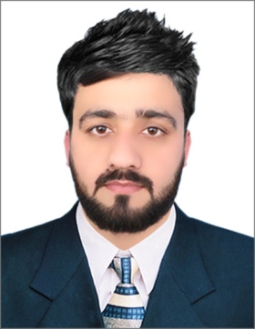

Dec 2019

Till Date

**MRHSM Hospital (Govt. Hospital)**

*Computer Operator (Store)*

**WORK**

A small business having the following facilities..

Graphics Designing, Printing, Pena Flex, Broushers, PVC Cards, Visiting Cards, 3D Boards, Online Services etc.

Manage Store Stocks availability, Deliveries, Order & Consumption.

**Golden Graphics & Designing Centre**

*Self Employed*

Sep 2018

Till Date

Part Time

Sep 2014

Feb 2019

Paper composing, Maintain Salaries, Examination record, Daily attendance and Results.

**Abaseen School & College Akbar pura NSR**

*Computer Operator*

Session (2010)

Marks 859/1050

1st Division

**SSC (Sciecne)**

*BISE Mardan*

**EDUCATION**

June 2010

July 2012

**FSC (Pre-Engineering)**

*BISE Peshawar*

Session (2012)

Marks 725/1100

1st Division

Sep 2014

**Diploma in Information Technology**

*BTPEP Islamabad*

Session (2014)

Marks 1140/1400

1st Division

**HOBBIES**

Professional Photography, Playing Games , Static Designs, Reading General books.

**COMPUTER OPERATOR**

**ma889947@gmail.com**

**0092-3159424815**

MUHAMMAD **ABUBAKAR**

The main object of my life is to live a successful and progressive life by making Achievements through my skills and efforts for the purpose to serve the Organization, and to help people for their progress in every field.

**ADDRESS**

**Village Camp Koroona P/O**

**Akbar Pura**

**Tehsil Pabbi**

**Distt. Nowshera KPK**

**Pakistan**

**Objectives**

**SKILLS**

Graphic Designing

Canva

Printing

MS Office

Corel Draw

Data Entry