Muhammed Zamil

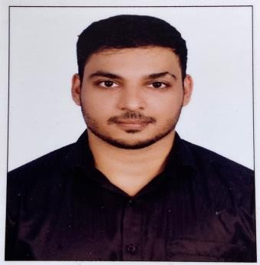

CONTACT

## Email: [muhammed0zamil@gmail.com](mailto:muhammed0zamil@gmail.com) Phone: 0527755456

**Address: Tower 1 , Near : Al ain Bus Station , Al ain , UAE**

EDUCATION

* **10th** SN THSS THOTTADA (2006)
* **12th** VHSC THOTTADA (2008)
* **CCNA** SEPCTRUM SOFTECH SOLUTIONS (2012)

LANGUAGES KNOWN

* English
* Malayalam
* Hindi

SKILLS

* Self-Awareness.
* Communication Skills.
* Problem Solving
* Leadership
* Time management
* Self-motivation
* Team work
* Ms office
* Hard ware and Networking
* ERP system

PERSONAL INFORMATION

* Date of Birth : 20/09/1990
* Gender : Male
* Marital status : Married
* Passport No : V4873183
* Nationality : Indian

# PERSONAL PROFILE

Results-driven professional with six years of comprehensive expertise in office assistant, office administration, and transport management. Adept at optimizing workflow efficiency, maintaining inventory accuracy, and ensuring seamless transportation logistics. Seeking a challenging role that capitalizes on my skills to contribute to an organization's success while continuing to enhance my abilities in a dynamic and growth-oriented environment

# EXPERIENCE

## Company Name: Qatar Trading and Transport company, Doha

**Designation:** Office Assistant **Duration:** May 2016 to June 2018 **Designation:** Office Admin **Duration:** July 2018 to March 2023

## Company Name: Fresh Layer Cafeteria, UAE , Al Ain

### Designation: Cashier

### Duration: from June 2023 to Present

**OFFICE ASSISTANT**

* + Maintaining a clean and organized office environment.
  + Greeting and assisting visitors and clients
  + Managing physical and electronic filing systems
  + Providing administrative support to senior staff members
  + Assisting colleagues with software and hardware inquiries

### OFFICE ADMIN

* Coordinate office activities and operations to secure efficiency and compliance to company policies.
* Supervise administrative staff and divide responsibilities to ensure performance.
* Create and update records and databases with personnel, financial and other data.
* Maintaining general office files, including job files, vendor files, and other files related to the company’s operations.
* Purchasing office supplies, equipment, and furniture.

### CASHIER

* Receiving payments and issuing receipts to customers.
* Track transactions on balance sheets and report any discrepancies
* Maintain clean and tidy checkout areas.
* Greeting customers as they arrive
* Assisting with or taking customer orders
* Putting takeout orders in containers or bags.

# DECLARTION

I sincerely proclaim that all the facts in my resume accurate, and I am responsible for their accuracy.

PLACE: Al Ain Muhammed zamil KP