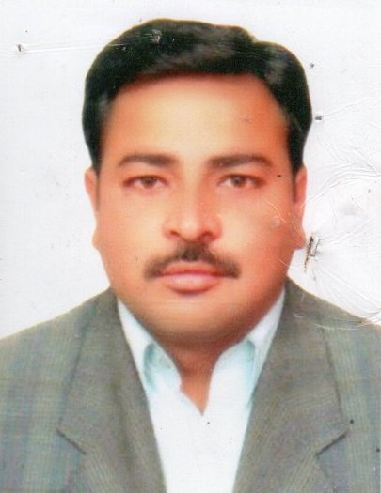**NASEER ALAM**

Al khail gate building 1-26

Apartment #706west zone

super market Dubai, U.A.E

Mob No: 00971-563732233

Email Address: [**alam.naseer99@yahoo.com**](mailto:alam.naseer99@yahoo.com)

|  |
| --- |
| **PERSONAL PROFILE AND KEY SKILLS:** |

I am an energetic, ambitious person who has developed a mature and responsible approach to any task that need to be undertaken, or situation that I am presented with. As a professionally qualified with seven years’ of experience in accountancy, am excellent in working with others to achieve a certain objective on time and with excellence.

* **Self-motivated**
* **Adaptable**
* **An eye for detail**
* **Communication**
* **Customer Service**

|  |  |  |
| --- | --- | --- |
| **EDUCATION:** | | |
| **Year** | **Awarding Body** | **Qualification** |
| 2011 | IOASH (U.K) | Conflict/Health & Safety Management |
| 2001-04 | Gomal University | Bachelor of Science |

|  |
| --- |
| **EMPLOYMENT HISTORY:** |

**15/01/2022 working with probiz real estate as property consultants currently working**

A consultant’s duties include meeting with clients, understanding requirements, conducting data analysis, presenting findings, formulating plans, arranging training, evaluating progress, and staying updated in their field.

Their day-to-day duties and responsibilities include: Contacting potential clients to offer them property consultancy services; Preparing and presenting .

**02/05/2020- 03/12/2021 worked as captain with CARS TAXI Dubai L.L.C**

Transport clients and/or packages to and from destinations.

Arrive at destinations on schedule.

Fulfill administrative needs, like office pickups.

Research and plan for traffic, construction and weather delays.

Use navigation applications to determine the best route.

**07/07/2018-12/02/2020 working as a “STORE SUPERVISOR FDC interiors L.L.C in Dubai, UAE .**

Keeping a record of sales and restocking the store accordingly.

Managing and training store staff.

Planning promotional campaigns for new products or specials.

Ensuring that the store is kept clean and organized.

Mediating any confrontations between staff and clients, and de-escalating the situation

**28/11/2012 to 01/02/2015 A & K CONVENIENCE STORE 2 Bar Gap Road OLDHAM.**

1. Maximize store income and achieve agreed performance targets.

2. Promote gift Aid to customers.

3 Maintain a high level of commercial awareness.

4.Open the shop between agreed hours of trading.

5.Maintain a clean & clear condition for health and safety.

6. Assist with stock generation.

7.Effective Communication with all customers.

8.Hands on approach to work.

**06/05/2015 to 10/12/2015 Lucky Cement**

As safety supervisor in lucky cement factory Pakistan.

Daily giving guidelines regarding safety to the worker.

Putting safety signs on the walls where necessary.

Checking the safety shoes and helmet and dresses.

**01/10/2010 to 15.11.2011  I.S.S. Security Ltd**

• Acting as a visual deterrent.

• Access & Egress control.

• Random staff & Vehicle Search.

• Patrols inside and outside of premises, random pocket search during patrol.

• CCTV monitoring, copying the images, provide these to the authorities if required.

• Gatehouse booking IN & OUT all Goods In/out Vehicles, Seal/remove seals from Vehicle.

• Reception duties for all visitors, issue cards, Log in/out, provide Parking facilities or info.

• Key Handling with key log in/out register and placing keys on designated locations.

• Safe Check, put in/take out valuable items from Safe, Seal & document all items in safe.

• Providing first response in all on-site Security issue in case of Fire/Medical etc.

• Write daily occurrence/incidence reports and report these to the comms/controller.

**15/12/2011 to 20/10/2012 Security Officer at ISS Security Ltd(Cheshire House Acorn Business Park, Heaton Lane, Stockport SK4 1AS United Kingdom**)

* Acting as a visual deterrent.
* Access & Egress control.
* Random staff & Vehicle Search.
* Patrols inside and outside of premises, random pocket search during patrol.
* CCTV monitoring, copying the images, provide these to the authorities if required.
* Gatehouse booking IN & OUT all Goods In/out Vehicles, Seal/remove seals from Vehicle.
* Reception duties for all visitors, issue cards, Log in/out, provide Parking facilities or info.
* Key Handling with key log in/out register and placing keys on designated locations.
* Locking and Unlocking Buildings, Checking all Fire Doors, seal/put break glass on doors.
* Safe Check, put in/take out valuable items from Safe, Seal & document all items in safe.
* Providing first response in all on-site Security issue in case of Fire/Medical etc.
* Write daily occurrence/incidence reports and report these to the comms/controller.

**19/05/2005-01/09/2010 Marketing Office at Sami pharmaceuticalLtd. Pakistan**

* Taking orders of the Pharmaceutical product from the Pharmacies and dealer.
* Updating Doctors,Pharmacies about the change in product or launch new.
* Meeting the existing clients and visit new costumers to boost sale of products.
* Meeting the new target customers and converting them into customers.
* Solving the problem and queries of existing dealers and customers.
* Searching for new dealers and clients.
* Giving all the details of the company to the upcoming dealers and explaining them policies for the dealership.
* Organizing events at the dealers place to attract more customers.
* Meeting dealers on daily basis and helping them in finding customers.
* Making daily sales and call reports and sending them to the seniors.
* Attending meetings and monthly closing at district office.

**PERSONAL DETAILS:**

* Name : Naseer Alam
* Fathr’s Name : Muhammad Bakhtiar
* Date of Birth : 15/04/1979
* Nationality : Pakistani
* Religion : Muslim
* Marital Status : Married
* Languages Known : English, Hindi, Punjabi, Urdu and Pushto

**PASSPORT DETAILS:**

* Passport No : AK 1755414
* Date of Issue : 08/05/2019
* Date of Expiry : 06/05/2024
* Visa Status : Residential Visa
* Driving license. : 749023 sharjah

**CONCLUSION & DECLARATION:**

I hereby declare that the above mentioned details are is correct & true to the best of my knowledge & belief.

**NASEER ALAM**