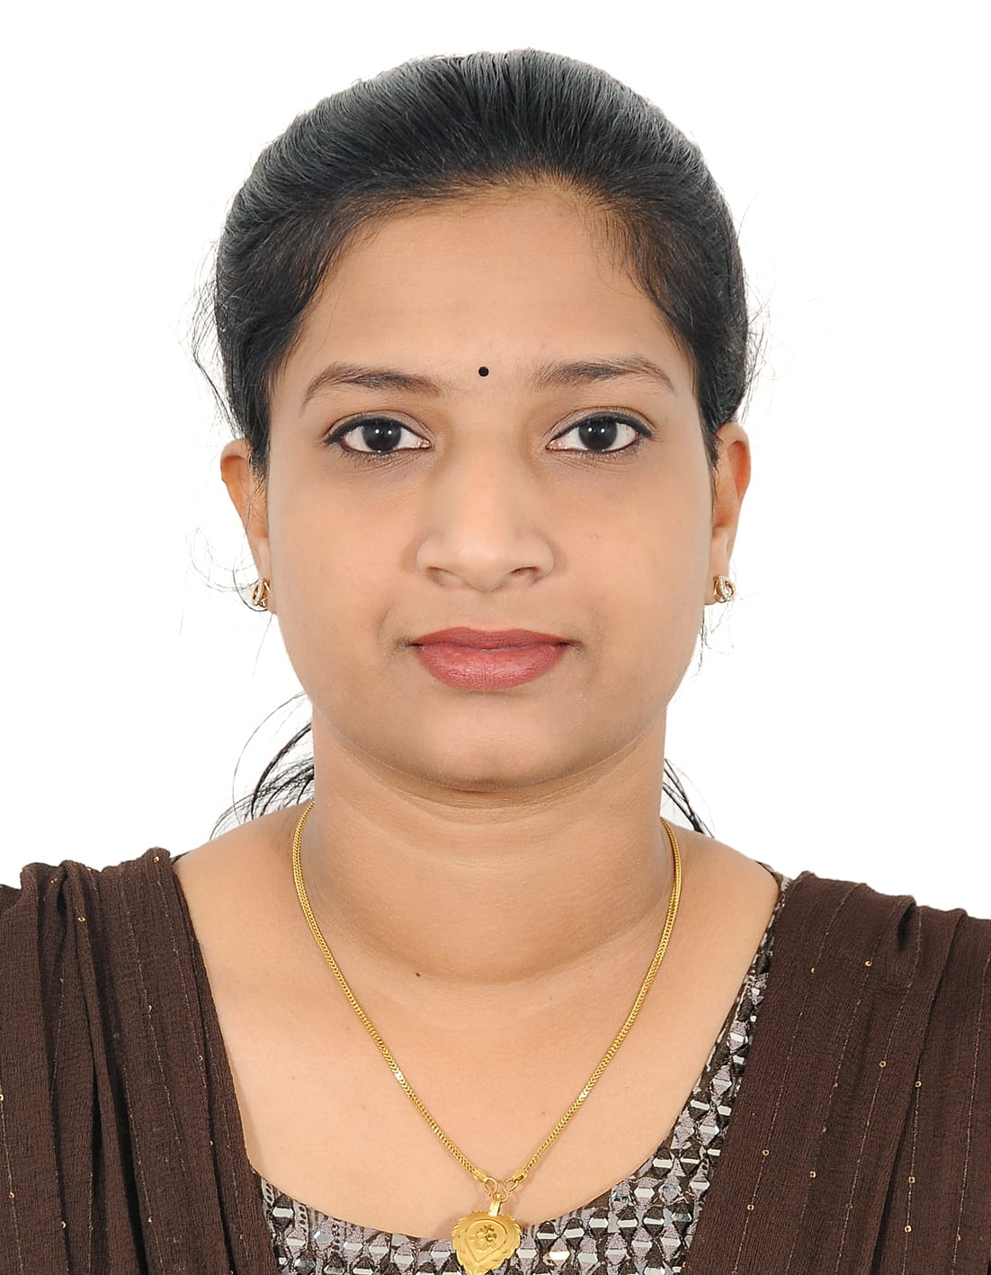

**NEERAJA PRAKASAN** [neerajaprakashan@gamil.com](mailto:neerajaprakashan@gamil.com) +971568287896

| **EDUCATION** |
| --- |

* Professional Diploma in Indian and Foreign Accounting International Association of Bookkeepers
* Graduation in english language and literature University of Calicut
* Higher Secondary Education in Commerce Government of Kerala

| **COMPUTER PROFICIENCY** |
| --- |

* PDIFAS
* SAP
* TALLY ERP 9
* QUICK BOOK
* PEACHTREE
* MS OFFICE(word,excel,powerpoint,outlook )
* MS EXCEL(Data analysis,formulas,pivot tables)

| **OBJECTIVES** |
| --- |

Highly organised and detail-oriented professional seeking a challenging position as an office assistant.Offering excellent computer

Proficiency,strong communication skills,and proven track record of providing efficient administrative support.

| **PROFESSIONAL EXPERIENCE** |
| --- |

**Devasura Inn,Kerala, INDIA Office assistant Nov 2018 - Mar 2020**

* Assisted in managing administrative tasks, including data entry, file management, and document preparation.
* Provided support in coordinating meetings, maintaining schedules.
* Handled incoming calls, greeted visitors, and directed inquiries to the appropriate departments.
* Managed inventory and supplies, ensuring availability of necessary office materials.
* Assisted in preparing reports, presentations, and correspondence as required.
* Collaborated with team members to ensure efficient workflow and office operations.

| **PERSONAL SKILLS** |
| --- |

* Strong organisational and time management abilities.
* Excellent verbal and written communication skills.
* Ability to work well both independently and within a team.
* Attention to detail and accuracy in all tasks.
* Problem-solving and multitasking skills.

| **ADDITIONAL INFORMATION** |
| --- |

**Address :** Al Mira tower,Al Majaz1,Sharjah

**Date of Birth :** 08/04/1998

**Languages Known :** English, Hindi and Malayalam.

**Visa Status :** Family Visa