CURRICULUM VITAE

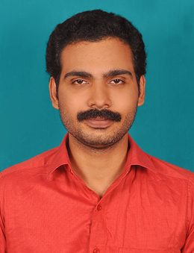
NIJIN C
CHENNALATH (H)
ARIYANNUR (PO)
Thrissur Dist
Pin 680102
Kerala, India.

E-mail: nijin89@gmail.com
Phone: +91-9037011680
Resi ; +91-4885235708

OBJECTIVE

My career objective is to work successfully, confidentially and honestly to achieve desired target of quality and quantity with professionally managed company/organization that provides growth opportunities. Seeking an accounting position in an aggressive organization. Long-term plans are to advance into a major management responsibility within the financial function of the firm.

EDUCATIONAL DETAILS

Qualification | University/Board | Year of Passing
M.Com | Calicut University | 2022
B.Com | Calicut University | 2009
Plus Two | Board of Higher Secondary Exams Kerala | 2006
S S L C | Board of Public Exams kerala | 2004

KEY SKILLS

Operating Systems Windows 9x, 2000, XP,
Office Tools MS – Word, MS – Excel, Foxpro & Dot net

EXPERIENCE

03/05/2010 – 30/04/2015
Working as an Accountant in BRD Securities Limited (NBFC), Kunnamkulam Kerala India
- 01/05/2015 – Presently Working
Working as Senior Accountant in BRD Finance Limited Kerala India
Job functions includes: Preparing day to day accounting transactions, Bank reconciliation,Online payments, Preparations of finalization.

SOFT SKILLS

- Confidence
- Learning Attitude
- Positive Thinking

PERSONAL PROFILE

Name : Nijin C
Sex : Male
Date of Birth : 19-09-1988
Father’s Name : C Narayanan
Mother’s Name : K JAYASREE
Nationality : Indian
Languages Known : English, Malayalam. Hindi
Passport Number : Z2979068

DECLARATION

I hereby declare that the above details given by me are true to the best of my knowledge.

Place ;

Date : NIJIN C

