Experienced professional with a versatile background in customer relations, sales support and administrative assistance across diverse industries. Proven ability to manage client communications, coordinate office operations and provide excellent support to teams and customers. Skilled in record-keeping, documentation, scheduling and multitasking to ensure smooth daily workflows. Strong interpersonal and organizational skills combined with a proactive approach to problem-solving. Seeking to leverage this broad experience in an Admin Cum Office Clerk role to contribute to efficient office management and effective administrative support.

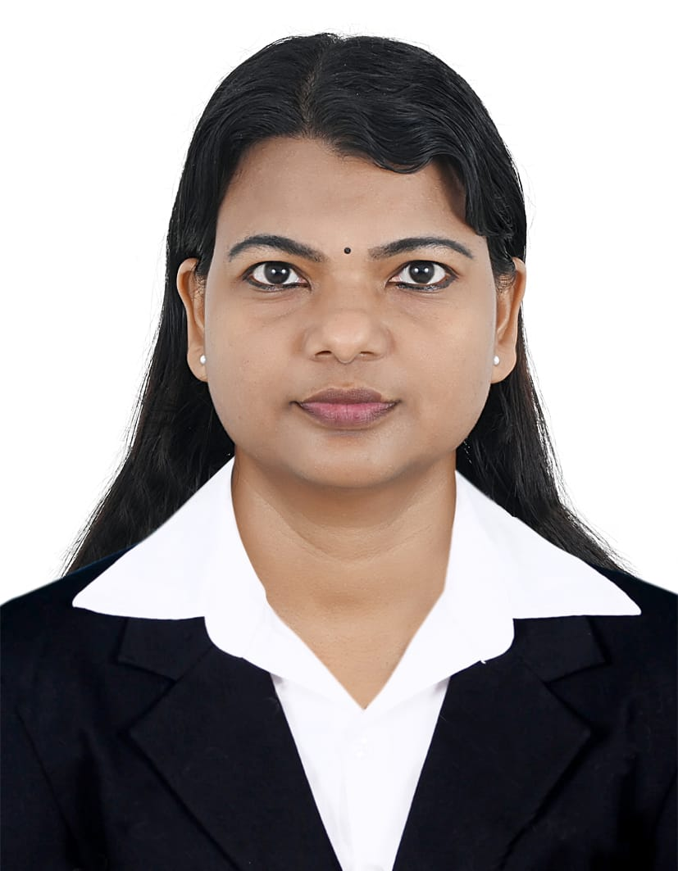

**NISHA R**

**ADMIN CUM OFFICE CLERK**

**SUMMARY**

UAE, Abu Shagara, Sharjah

aleenaaash@gmail.com

+971561800531

+91 7034373205







**EDUCATION**

**BACHELOR OF ARTS | 2014**

Kerala University, India

**PLUS TWO | 2005**

Board of Higher Secondary

Examination, Kerala

**SSLC | 2003**

Board of Public Examination, Kerala

**PROFESSIONAL SKILLS**

* Office Administration
* Document Management
* Data Entry
* Attention to Details
* Team Work
* Office Supplies Management
* Customer Relationship Management
* Client Retention
* Complaint Resolution
* Customer Satisfaction
* Communication Skills
* Sales Coordination
* Sales Administration
* Call Handling
* Process Improvement
* Time Management
* Office Supplies Management

**WORK EXPERIENCE**

**SUPPORTING STAFF | 2024 - Present**

THE WEST MINISTER SCHOOL, DUBAI, UAE

* Assisted teaching staff in preparing classroom materials and resources.
* Helped maintain cleanliness and orderliness in classrooms and common areas.
* Supported students during activities and guided them as needed.
* Managed distribution and collection of learning supplies.
* Monitored student attendance and reported discrepancies.
* Provided basic first aid to students when required.
* Assisted in organizing school events and activities.
* Coordinated with other staff members to ensure smooth daily operations.
* Helped manage student belongings and lost-and-found items.
* Assisted with arrival and dismissal procedures for students.

**SENIOR CUSTOMER RELATION EXECUTIVE** **| 2020 - 2024**

KLM AXIVA FINVEST LTD

* Managed daily interactions with key customers to ensure satisfaction and retention.
* Responded promptly to client inquiries and provided detailed information on financial products.
* Coordinated with internal teams to resolve customer issues efficiently.
* Monitored customer accounts and followed up on pending requests or concerns.
* Assisted in developing strategies to improve overall customer experience.
* Provided guidance and support to junior customer service staff.
* Maintained accurate records of customer interactions and transactions.
* Facilitated meetings and calls with clients to discuss account status and updates.
* Assisted in onboarding new customers and educating them on company services.
* Supported marketing efforts by gathering customer insights and preferences.

**SALES SUPPORT EXECUTIVE | 2018 - 2019**

MARIKAR MOTORS

* Assisted the sales team with daily administrative tasks and customer follow-ups.
* Prepared sales documents and quotations as per customer requirements.
* Coordinated communication between customers and sales representatives.
* Maintained updated records of sales orders and customer information.
* Supported inventory management by tracking stock availability.
* Scheduled appointments and test drives for prospective customers.
* Monitored delivery schedules and ensured timely dispatch of vehicles.
* Assisted in processing sales contracts and related paperwork.

**CUSTOMER SERVICE EXECUTIVE | 2017 - 2018**

CHEMMANUR CREDITS AND INVESTMENTS LTD

* Responded to customer inquiries via phone, email, and in-person.
* Assisted customers with account-related questions and transactions.
* Recorded and updated customer information accurately in the system.
* Addressed and resolved complaints or service issues in a timely manner.
* Guided customers through product and service options to meet their needs.
* Coordinated with internal departments to ensure prompt issue resolution.
* Provided information about loan products and investment plans.
* Scheduled appointments and follow-ups for customer meetings.

**LANGUAGES**

English

Malayalam

Hindi

Tamil

**COMPUTER SKILLS**

* ERP Software
* MS Word
* MS Excel
* MS PowerPoint

**PERSONAL DETAILS**

Nationality : Indian

D.O.B :  05-11-1990

Gender : Female

Marital Status : Single

Passport No : X9598294

**HOBBIES**

* Music
* Travelling
* Movies

Hereby declare that all the details mentioned above are in accordance with the truth and fact as per the knowledge.

**NISHA R**

**DECLARATION**