CURRICULUM VITAE


NAJEEB KARAPPAN VEETTIL
Mob. : No. 050 – 9394504
Email : kuttippuramnajeeb@gmail.com

CAREER OBJECTIVES
Aspiring for a suitable job to establish my growth in a creative environment where I can use acquired skills and hard work to prove myself.

EDUCATIONAL QUALIFICATION
- S.S.L.C - Board of Public Examinations, Kerala, India.

OTHER TECHNICAL QUALIFICATION
- Operating of Office Machines like Copier, Scanner & Fax etc.
Highlights of Qualification:
- Sincere and Dedicated
- Disciplined, straightforward and Honest
- Fast Learner and Excellent team Player
- Positive Attitude, willingness to world hard, Flexibility to Adopt Change, Sincere
- Strengths:
- Proven Problem solving skills, good conceptual foundation, attitude for learning new things, ability to work under pressure and willing to relocate.
- Strong Interpersonal and Leadership Skills.

Work Experience:
● TOTAL WORK EXPERIENCE – 16 Years
● U.A.E. EXPERIENCE – 7 Years

Work Experience in – U.A.E.
June 2015 till January 2017 – DREAM MART HYPERMARKET L.L.C
Designation - Supervising &Vegetable Purchasing
Duties & Responsibilities: -
- Responsible for the quality check and purchase of vegetables on daily basis
- Responsible for the arrangement and display of vegetables in the market
- Price check and instructions to the team

2008 August to till April 2015 - Nael & Bin Harmal Hydro Export Est.
(Infrastructure contractors in Abu Dhabi, Al Ain and Dubai)
Designation - Office Assistant / Receptionist

Duties & Responsibilities: -
- Attending Telephone Calls
- Surfing net for getting up to date online information.
- Clearing Facsimile Messages and couriers
- Maintains confidential files and office records.
- Handling Inquiries and complaints.
- Receiving the visitors and guests.

2005 March to 2008 June - AL IRFAD Supermarket, Sharjah, UAE.
(Retail & Wholesale Supermarket group working in UAE.)
- Designation - Sales Executive, Cashier & Supervisor
Nature of Works
- Meeting sales Target
- Introduce New Product
- Company Dealing with New Clients
- Keeping Good Relation with existing Clients

2017 to 2019(still now) - BAQER MOHIBI Supermarket, DUBAI, UAE
- Designation - Supervisor (Vegetable section)

Work Experience in INDIA
1999 May to 2005 - Lulu Textiles, Kerala, India
Designation - Sales Executive
Duties & Responsibilities: -
- Extensive marketing to increase the market value of the company’s products
- Conducting customer meeting for negotiations
- Handling customer related issues
- Co-ordinate with suppliers and Management in a good manner

1996 March to 1999 - City Silks, Kottakkal, Kerala
Designation - Sales Executive cum Cashier

Duties & Responsibilities: -
- Maintains confidential files and office records.
- Handling Cash and Bank Transactions
- handling Copier, Scanner & Fax etc.
- Attending the telephone calls.

Summary of Skills:
- Highly organized and dedicated with a positive attitude.
- Strong office administrational and manage abilities.
- Ability to work in under pressure
VISA STATUS
- Visit visa

PERSONAL DETAILS
- Date of Birth : 15 May 1976
- Sex : Male
- Nationality : Indian
- Religion : Islam
- Marital Status : Married
- Languages Known : English, Hindi, Arabic & Malayalam (Mother Tongue)

PASSPORT DETAILS
- Passport No : F7916526
- Date of Issue : 11 December, 2006
- Date of Expiry: 10 December, 2016
- Place of Issue : Dubai

LICENCE DETAILS

- INDIA :
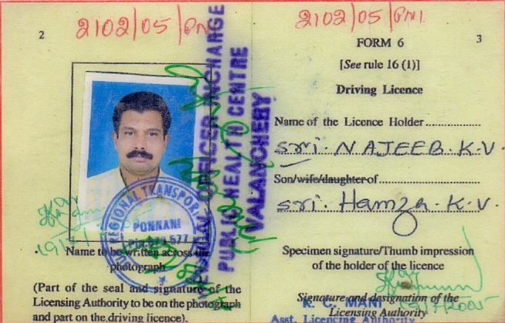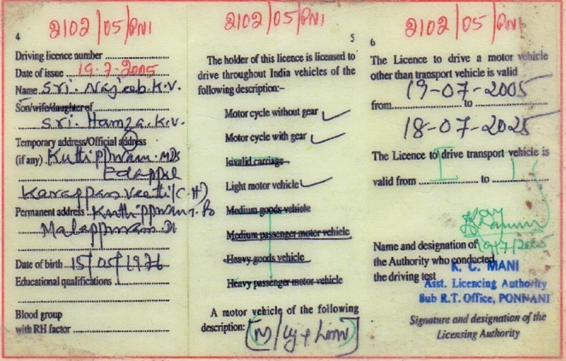

- U A E :
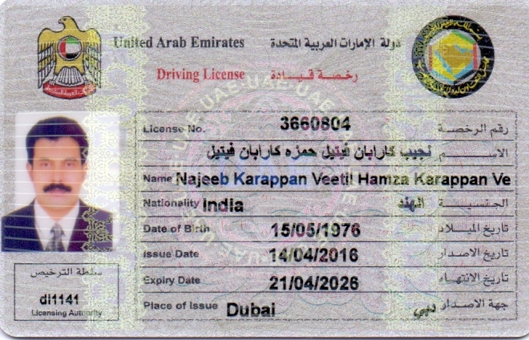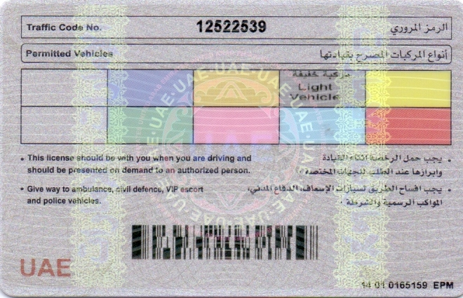

DECLARATION:

I hereby declare that the information furnished above is true and fair to the best of my knowledge and belief.

NAJEEB.K.V DUBAI, U.A.E

