|  |
| --- |
| CURRICULUM |

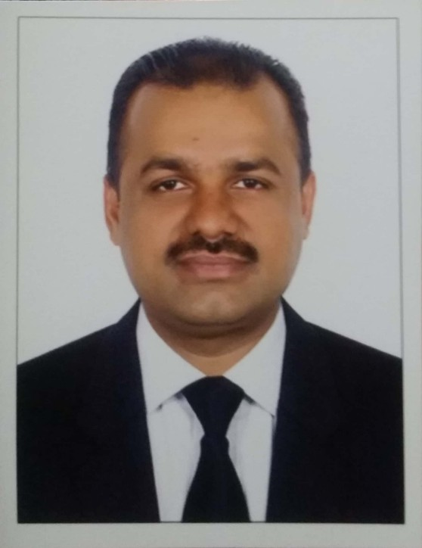

NAVEED UR REHMAN

**Mobile Pakistan : 0092-3451123209**

**Whatsapp No : 0092-3451123209**

**Email :** [**rehmannaveed26@gmail.com**](mailto:rehmannaveed26@gmail.com)

**POST APPLIED FOR DRIVER**

**CAREER OBJECTIVE**

To become a part of a dynamic group where I could further explore the skills and capabilities, which I gained in the whole working career and in present job experience, and to serve in a challenging work environment with equally vast opportunities of career development based upon achievements results.



PERSONAL INFORMATIOM

* **Gender Male**
* **Nationality Pakistani**
* **Date of Birth 01/01/1982**
* **Married Status Married**

# 

# PASSPORT DETAIL

* Passport No BX9672252
* Date Issue 27/12/2020
* Date of Expiry 26/12/2025
* Visa Status No Have Visa (Now I am in Pakistan)



# LICENSE DETAIL

* **License Number 3890058**
* **Date Issue 21/12/2018**
* **Date of Expiry 21/12/2025**
* **Place of Issue Dubai UAE**
* **Category Light Vehicle Number 3 ( Manual )**

# 

# ACADEMIC QUALIFICATION

* **Matric Passed from Pakistan**
* **Computer knowledge ( MS Office )**

**LANGUAGE DETAIL**

* **English**
* **Urdu**
* **Hindi**
* **Punjabi**

# 

**WOEK EXPERIENCE**

1. **Working for Arabia Taxi as a Taxi Driver Dubai UAE in 02 Year.**

# Working for Delivery Driver in noon.com or others in 02 Year.

1. **Working for Treading company as Clark & Documentation Controller HR department in Pakistan 10 Years.**

# 

**PROFIESSIONAL APPRAISAL**

* Complete knowledge for all locations of UAE.
* Able to plan journey according to the rush hours.
* Smart, Enthusiastic, Energetic, Obedient, Punctual.
* Pleasing Personality and able to work under pressure.
* Can work individual with minimum supervision.
* Able to grasp knowledge faster.

# DECLARATION:

I hereby declare that the above statements are true and best of my knowledge and belief

**NAVEED UR REHMAN**