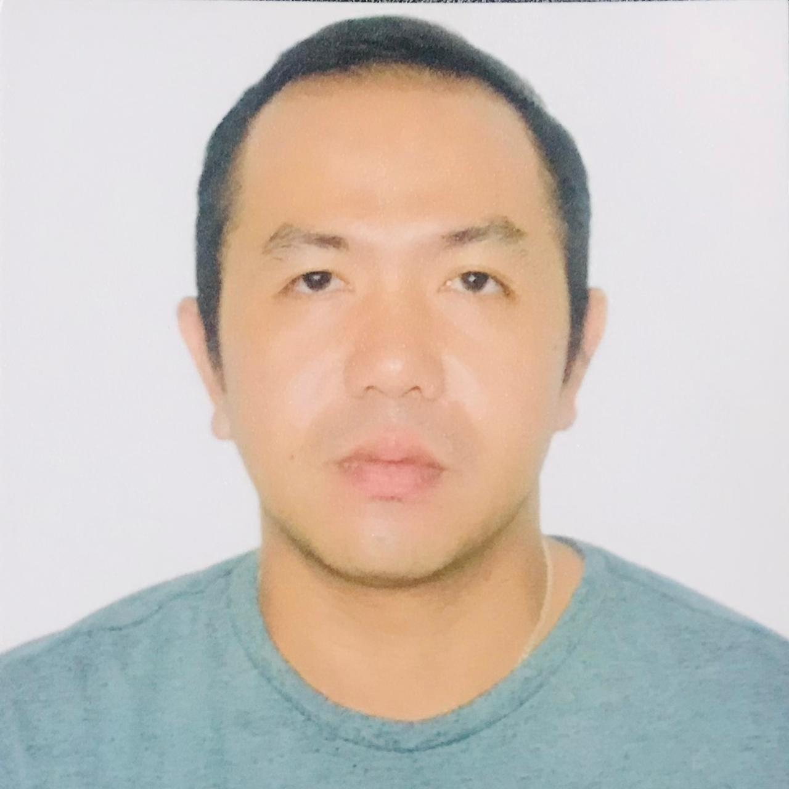
Paul Vincent R. Bagatila  Al Satwa, Dubai U.A.E.  +971 563547180  bagatilap@gmail.com  Visa Status: Visit Visa  EDUCATION  University of Iloilo  Iloilo City, Philippines  Bachelor of Science in Marine Engineering (Under Graduate)  S.Y. 2013-2014  Jaro National High School  Iloilo City, Philippines  Secondary Education  S.Y. 2006-2010  Personal Information:  Date of Birth: April 06 1993  Religion: Roman Catholic  Nationality: Filipino  Gender: Male  Civil Status: Single |  | WORK EXPERIENCE  Sales Man  JKS Vape Shop  Iloilo City, Philippines  January 2024 to Octoberr 2024  - Welcome guests with a smile and identify customer needs.  - Explain products to customers and ask questions to determine the right product for them.  - Process customer orders and thank them for visiting us.  - Investigate, troubleshoot, and resolve customer complaints with the assistance of your management team.  Waiter (on Call)  Alicia Catering  Iloilo City, Philippines  January 2022 to December 2023  - Greeting guests and taking drink and food orders  - Staying attentive to the needs of guests in the dining area  - Following health code standards with regards to the handling of food  - Performing shift duties like delivering racks of cups to the service station, rolling silverware, pre-bussing tables, and wiping tables  Screen Printing/ Clothing Designer  INEXT SPORTWEAR  Iloilo City, Philippines  January 2017to February 2020  - Conceptualize outfits and sketch them to clarify the concept to the stakeholders  - Manage the design process from conception to final styling and beyond  - Choose fabrics and trims.  - Work with other fashion designers or assistants to choose seasonal themes.  - Make edits to the line and build new concepts  Sales Representative  GOLD STRING COMPANY  Iloilo City, Philippines  December 2015 to December 2016  - Present, promote and sell products/services using solid arguments to existing and prospective customers  - Perform cost-benefit and needs analysis of existing/potential customers to meet their needs  - Reach out to customer leads through cold calling  - Achieve agreed upon sales targets and outcomes within schedule  - Supply management with reports on customer needs, problems, interests, competitive activities, and potential for new products and services.  - Keep abreast of best practices and promotional trends  - Continuously improve through feedback  Computer Encoder (Home Base)  Iloilo City, Philippines  March 2013 to September 2013  - Organize and maintain files and databases, ensuring all records are up-to-date and easily accessible.  - Perform regular data entry tasks, including updating information, creating new records, and deleting obsolete ones.  - Collaborate with team members to ensure data accuracy and consistency across all systems.  Car Painter  JB LUCKY COMPANY  Iloilo City, Philippines  February 2011 to January 2013  - Preparing and cleaning vehicles before painting  - Mixing paint to match the required color  - Applying layers of primer and paint to vehicles  - Inspecting for defects and ensuring a smooth finish  - Polishing and waxing vehicles after painting  - Carrying out minor repairs

