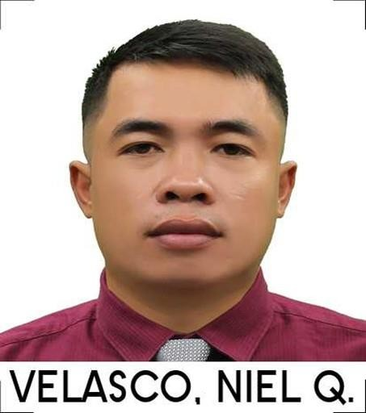

WORK EXPERIENCE
ALLDAY MINIMART
Dubai UAE
Sales Personnel
From 16th of Dec 2022 to Present
Job description
- Sales
- Receiving delivery’s
- Inventory of stocks
- Product Knowledge and selling
- identify the product according to there section.
- Knows how tomake a good coffee; esspresso, americano, latte, cappuccino.
- Knows how to handle bakery section.

Contact No. 0529045242 Email:nielvelasco34@gmail.com nielvelasco62@yahoo.com
Age: 37
Height: 5’4”
Weight: 66kg
Civil Status: Married Religion: Catholic

EDUCATION
- WEST NEGROS UNIVERSITY
- June 2009 – May 2010
- Bachelor of Science in electrical engeering
Vice President of Electrical Student Society in School Campus.
Member of the Provincial Electrical Student Council.

- CITY OF TALISAY March 2005 – June 2008 INFORMATION AND
COMMUNICATION TECHNOLOGY
  - Member of the Student Council
  - Member of the Computer Operation Society
  - Microsoft Office Word and Excel.

- INFORMATION AND COMMUNICATION TECHNOLOGY
- June 2004 – May 2005
- Computer Operation Operator Talisay City, Negros Occidental

Skills
- Computer Literate
- Knows regarding electrical installation Drafting skills
- Driving skills (Manual and Automatic Transmission)
- Barista

Certificate:

Basic Food Safety Training
Occupational Health Certificate

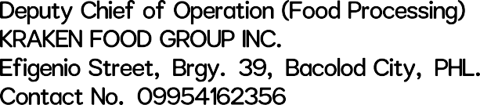
2nd February 2011 –December 15 2017
  - Handled a team of food processing (Shrimp Tempura).
  - Conceptualize marketing campaigns.
  - Prepared all necessary documents for shipment
  - Handled marketing communications.
  - Handled direct labors payroll.
  - Secure harvest from the shrimp farm.
  - Handled payments for harvest.
  - Prepared all necessary costing for pricing of finish goods.

May 2010–August 2010
    - Accurately and efficiently encode all data that needs organizing and recording.
    - Confirm that entered data accurately aligns with original documentation
    - Organize and maintain original paper evidence
    - Assure files are properly prepared and saved to backup drives
    - Transcribe, scan or photocopy hard copy documents and forms as needed
    - Self-audit of work, checking for errors or duplication
    - Organize files in a logical and manageable fashion
    - Adhere to and meet set schedules and deadlines
    - Input, track, and maintain all encoded data and records
    - Perform any other office tasks that management requires assistance with (sending emails, answering phones, etc.)
    - Report any major errors or inconsistencies to uppermanagement



September 2004–February 2010
      - Performing general electrical maintenance.

      - Installing, maintaining, and repairing electrical control, wiring, and lighting systems.

      - Inspecting transformers, circuit breakers, and other electrical components.

      - Troubleshooting electrical issues using appropriate testing devices.

      - Repairing and replacing equipment, electrical wiring, and fixtures.

      - Following National Electrical Code state and local building regulations.

      - Performing circuit breaker corrective maintenance.

      - Maintaining good knowledge of heating and air conditioning systems as well as various testing equipment.

NIEL QUINTANILLA VELASCO
Applicant

