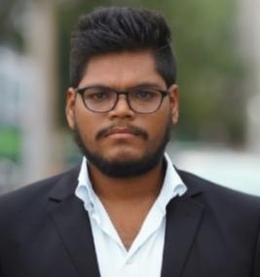

s

**OBJECTIVE**

I seek challenging opportunities when I can fully use my skills for success of the organization. Looking to earn more experience in the field while helping your company to reach their goals in excellent customer service.

**EXPERIENCE**

**15-04-2023 to 22-09-2023 - Anmol Electronics Dubai UAE**

## Admin cum Sales Coordinator

* Documentation and Update of Customer and Product Data Base.
* Assisting the Sales department on month end closing meeting with Client & customers.
* Enquiring and updating the sales team with new requirements of customer.

**26-07-2022 to 15-03-2023 - Star Health and Allied Insurance Company Ltd Hyderabad India**

## Admin cum Advisor

* Documentation and Ledger of Claims.
* Call and clarify customer queries.
* Reminder Calls on policy expiry and new updates to the customer.

**25-08-2021 to 25-07-2022 - LSG SKYCHEF’S PVT LTD Hyderabad India**

## Role: Flight Attendant Supervisor

* Coordinating - Filling catering into flights.
* Ensuring the supply of food and beverages into the flights.
* Refreshments supply coordinator for passengers, pilots and cabin crew.

**EDUCATION**

**2017-2022 - OSMANIA UNIVERSITY**

Bachelor of Commerce (Computers) – CGPA: 7.67

**SKILLS**

* Data entry and record keeping
* Time Management
* Financial Analysis
* Efficient in MS Office (Word, Excel, Power Point), V lookup
* Customer Service

**LANGUAGES**

* English
* Hindi
* Telugu
* Marathi

**ADDITIONAL INFORMATION**

Passport Number: V1616741

DOB 01-11-1997